# Adding Members to a SonicAgile Project

You can add an unlimited number of team members to a SonicAgile project. Consistent with Agile, every member of a project can do everything in a project. For example, every member of a project can create, delete, edit stories, epics, and tasks.   
  
The only thing that a normal project member cannot do is access Project Settings. Only the project owner (the creator of the project) can modify Project Settings.

## Adding Members by Email

If you are the project owner then you can invite a new person to your project using the person's email address. Follow these steps:  
  
1. Click the **Settings** link to navigate to Project Settings  
  
2. Select the **Members** tab  
  
3. Enter the person's email address in the **Invite New Member** section  
  
When you invite a new member by email, an email is sent to the person that contains a link back to SonicAgile. If the person registers at SonicAgile using the same email address then the person is added to your project automatically.  
  
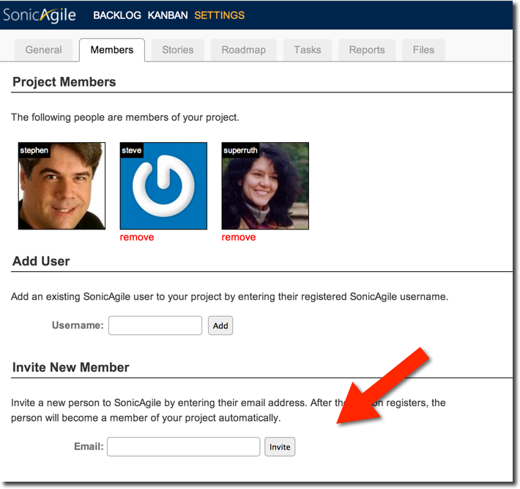

## Adding Members by Username

If you know that a person has already registered at SonicAgile, and you know the person's username, then you can invite the person to your project by entering their username:  
  
1. Click the **Settings** link to navigate to Project Settings  
  
2. Select the **Members** tab  
  
3. Enter the person's SonicAgile username in the **Add User** section  
  
The person is added to your project immediately.  
  
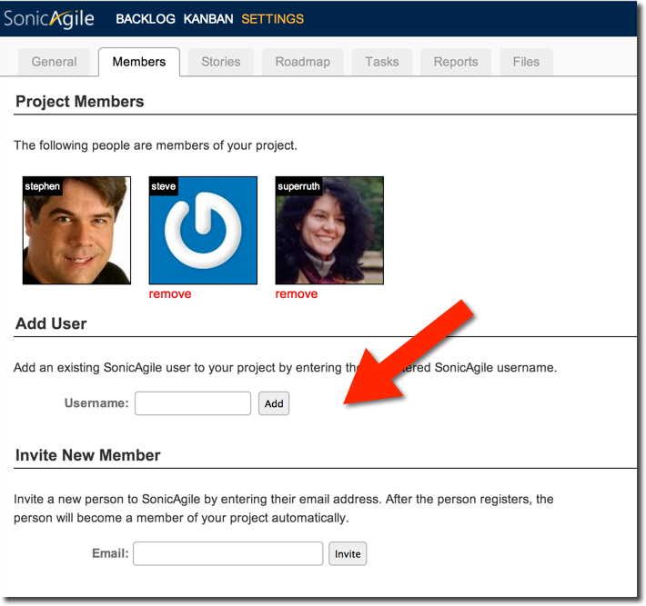

## Removing Members

The project owner can remove a person from their project at any time. Follow these steps:  
  
﻿1. Click the **Settings** link to navigate to Project Settings  
  
2. Select the **Members** tab  
  
3. Click the **remove** link under the project member that you want to remove   
  
Removing a project member does not remove any of the project member's stories, discussion messages, or anything else that the project member created. However, after a project member is removed from a project, the project member can no longer access the project.

## Leaving a Project

A member of a project can decide to leave a project at any time. After a member of a project leaves, the person cannot access the project unless the person is re-added by the project owner.  
  
Follow these steps to leave a project:  
  
1. Click your username to navigate to your Profile (top-right of the screen).  
  
2. Click the **Projects** tab to see the list of projects that you are a member of.  
  
3. Click the **leave** link next to the project that you want to leave.  
  
You cannot leave your own project.

**Breaking Stories into Tasks with SonicAgile**

You might need to break a single story into multiple tasks. Completing a story might require the work of multiple people in multiple roles.   
  
Imagine, for example, that your story is "Create a Shopping Cart". You might want to break this story into the following tasks:  
  
1. Write the Code.  
2. Do the UI Design.  
3. Test the Shopping Cart.  
  
The "Create a Shopping Cart" story can be broken into three tasks performed by three different people: a coder, a designer, and a tester. After you break a story into tasks, you can assign different tasks to different people and you can track progress on each task individually.  
  
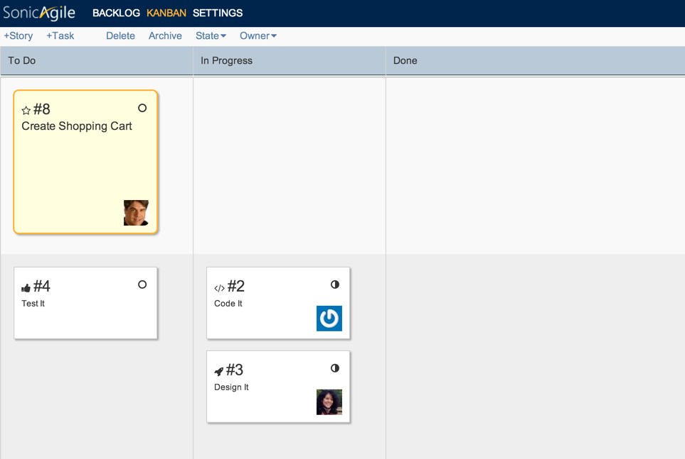

**Enabling Tasks**

Before you can break a story into tasks, the project owner must first enable Tasks. Tasks is an optional feature that the project owner (the person who created the project) must enable in Project Settings. Follow these steps:  
  
1. Click the **Settings** link to navigate to Project Settings  
  
2. Select the **Tasks** tab  
  
3. Check the checkbox labeled **Enable tasks**

**Breaking a Story into Tasks**

The easiest way to break a story into tasks is on the Kanban. Follow these steps to create a new task:  
  
1. Click the Kanban link to navigate to the Kanban  
  
2. Select a story on the Kanban by single-clicking the story with your mouse  
  
3. Click the +Task button that appears in the Kanban toolbar  
  
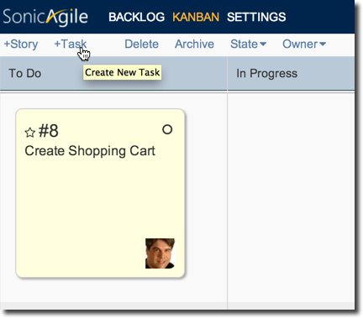  
  
When you create a new task, you can enter the following information:

* **Type** - The type of the task that needs to performed. For example, Code or Review.
* **Owner** - The person assigned to complete the task.
* **Description (optional)** - A full description of the task.
* **Original Estimate (optional)**- If you enable Time-Tracking then you can enter a time estimate for completing the task.

After you create the task, the task will appear on the Kanban directly beneath its story. Just like a story card, you can drag a task card back and forth among the To Do, In Progress, and Done columns. In other words, you can track progress on each of a story's tasks in the same way as you can track progress for the story.

**Uncompleted Tasks Warning**

If you drag a story to the Done column in the Kanban (or otherwise change the state of a story to Done) and the story has tasks that are not Done then a warning is displayed.  
  
First, a warning icon is displayed on the story card on both the Backlog and the Kanban. The warning appears on the top-right corner of the story card.  
  
A warning message also appears when you open the story. When a story is marked as Done with uncompleted tasks then you see the warning "You can't mark a story as done with uncompleted tasks".  
  
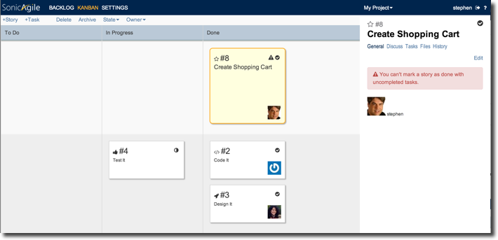  
  
To make the warning go away, you must do one of the following:

* Change the state of all of the tasks to Done (for example, by dragging all of the tasks to the Done column on the Kanban).
* Change the state of the story to In Progress or To Do (for example, by dragging the story to either the In Progress or To Do column on the Kanban).
* Delete the tasks.

**Customizing Task Types**

The project owner can customize the types of tasks that can be created in a project. By default, the two task types are Code and Review. However, in a software project, you might want to create additional task types such as:

* UI - So you can track when the UI design is completed.
* UX - So you can track when usability tests are completed.
* Test - So you can track when code is tested.
* Merge - So you can track when code is merged into source control.
* Doc - So you can track when documentation is written.

Of course, you can create any set of tasks types that you need. Follow these steps to create custom task types:  
  
1. Click **Settings** to navigate to Project Settings.  
  
2. Select the **Tasks** tab.  
  
3. In the **Task Types** section, you can add or delete task types.  
  
When you create a new task type, you select an icon and a name for the task type. You can pick any icon that you want from the select list and you can pick any name that you want.  
  
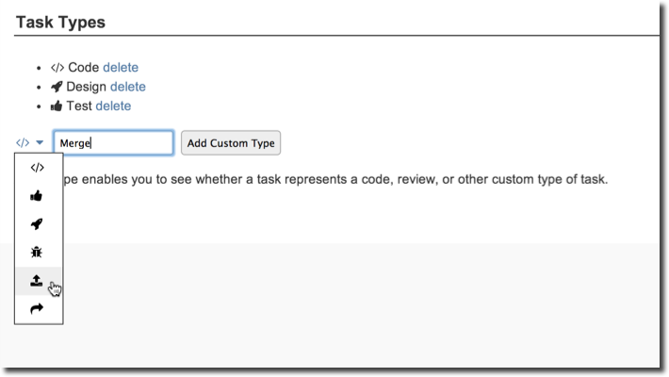  
  
When you delete a task type, you can delete a task type only when there are no tasks of that type. For example, if you have created a Test task type then you cannot delete that type until you change all of the tasks of that type to another type.

# Creating Multiple Projects with SonicAgile

SonicAgile enables you to create an unlimited number of projects. For example, you can create a different SonicAgile project for each software application that you are building. Each project has its own Backlog, Kanban, Roadmap, and project members.

## Adding a Project

Follow these steps to create a new project:  
  
1. Click your **username** link to navigate to your profile (top-right of the screen).  
  
2. Select the **Projects** tab.  
  
3. Enter a new project name and click the **Create** button.  
  
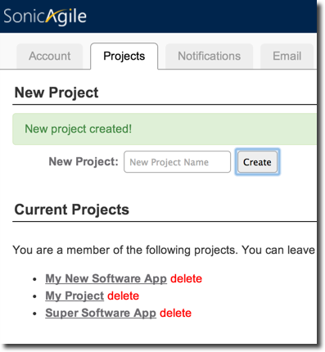  
  
  
You can navigate to a project by selecting the project from the Projects select list.  
  
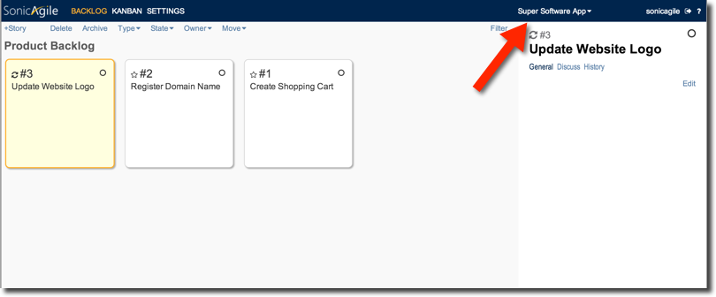

## Deleting a Project

You can delete a project at any time. After you delete a project, the project is gone forever. Any stories, discussion messages, tasks, and epics are deleted forever.  
  
Follow these steps to delete a project:  
  
﻿1. Click your **username** link to navigate to your profile (top-right of the screen).  
  
2. Select the **Projects** tab.  
  
3. Click the **delete** link next to the project that you want to delete.

**Importing and Exporting Stories with SonicAgile**

SonicAgile supports importing and exporting Comma-Separated Value (CSV) files. Because Microsoft Excel supports the CSV file format, this means that you can import and export your Backlog to Microsoft Excel.  
  
Exporting and importing stories is useful when you want to share a SonicAgile Backlog over email. You can share a Backlog with people who are not part of your SonicAgile project. You can export the Backlog to Excel, make changes to the Backlog in Excel, and import the Backlog again.  
  
Importing stories is also useful when you want to transfer work items from another project management tool such as Microsoft Team Foundation Server or JIRA. 

**Export All Stories from the Backlog**

You can export all of the stories from your backlog to a CSV file by following these steps:  
  
1. Navigate to your Backlog.  
2. From the Backlog toolbar, open the Advanced menu (top-right).  
3. Select Export.  
4. In the Export Stories dialog, click Export Stories.  
  
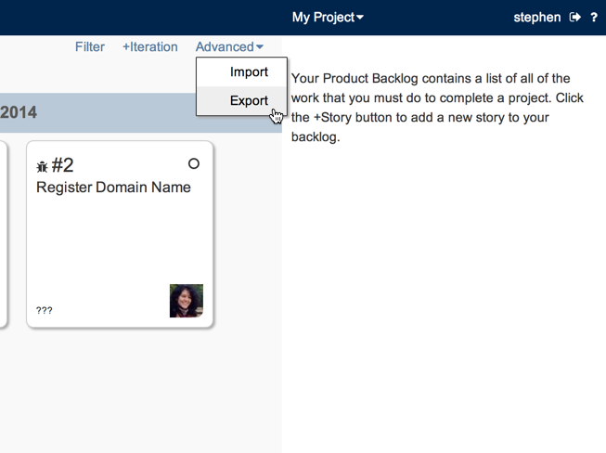  
  
Here's a sample of what the exported CSV files looks like:  
  
﻿id,title,state,owner,type,tags,points,epic,archived,deleted,description

1,Implement Voice Over IP and blah,In Progress,steve,Change,,0,,FALSE,FALSE,

2,Register Domain Name,To Do,superruth,Bug,,0,,FALSE,FALSE,

3,Update website logo,Done,superruth,Feature,,0,,FALSE,FALSE,

7,Update to Latest Version of MongoDB,To Do,stephen,Change,,0,,FALSE,FALSE,

5,Research LinkedIn Integration,In Progress,,Feature,,0,,FALSE,FALSE,

8,Create Shopping Cart,To Do,stephen,Feature,,0,,FALSE,FALSE,

6,Create Product Catalog and blee,In Progress,stephen,Feature,,0,,FALSE,FALSE,  
﻿  
Stories are exported in order of priority. If you have Iterations enabled then stories are grouped by iteration.  
  
The exported CSV file will contain different columns depending on what SonicAgile features you enabled. For example, the **points** column will appear only when you enable Agile Estimation.  
  
The **archived** column represents whether a story is archived or not. When you archive a story, the story no longer appears on the Backlog or Kanban. To see the story, you must open the Filtered Backlog.  
  
The **deleted** column represents whether or not the story has been deleted. When you export stories, **deleted** will always be FALSE.  The **deleted** column is useful when you import stories. You can use the **deleted** column when importing stories to the Backlog to permanently stories from the Backlog.

**Export Filtered Stories from the Backlog**

Instead of exporting your entire backlog, you can export a filtered subset of stories from your backlog. For example, you might want to export all stories owned by Fred. Follow these steps:  
  
1. Navigate to your Backlog.  
2. In the Backlog toolbar, click the Filter link.  
3. Filter the stories in your Backlog. For example, filter the stories by owner.  
﻿4. From the Backlog toolbar, open the Advanced menu (top-right).  
5. Select Export.  
6. In the Export Stories dialog, click Export Stories.

**Importing Stories into the Backlog**

You can import stories into your backlog a CSV file. Here's how it works:

* If a row does not have a value for the **id** column then a new story is created.
* If a row has a value for the **id** column then an existing story is edited.
* If a row has a value for the **id** column and the row has the value TRUE for its **deleted** column then the existing story is deleted.

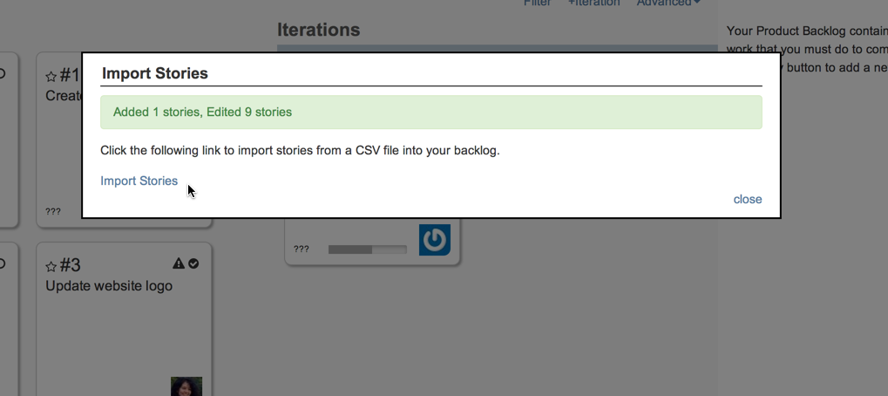  
  
When adding stories, the only required column is the **title** column. Imagine, for example, that you want to quickly import a list of stories that you created in Notepad:  
  
﻿title

Build a Shopping Cart

Create a Product Catalog

Register a Domain Name  
  
You can create the list of stories using Notepad and save the file with the extension .csv. Next, you can import the file by following these steps:  
  
﻿1. Navigate to your Backlog.  
2. From the Backlog toolbar, open the Advanced menu (top-right).  
3. Select Import.  
4. In the Import Stories dialog, click Import Stories.  
  
Be aware that the CSV file must be a plain text file. If you save a Microsoft Word file, for example, then the file will not be plain text. Use Microsoft Excel and save the file as CSV or create the file with Notepad.  
  
When importing stories, you can use the following columns (all of the columns are optional with the exception of the title column):  
  
﻿**id** - The story id.  
**title** - The story title.  
**state** - The story state. Possible values are**To Do**, **In Progress**, and **Done**.  
**owner** - The username of the owner of the story.  
**type** - The type of story. For example, **Feature**, **Bug**, **Cha﻿nge**.  
**tags** - The tags associated with the story - this is a comma delimited list.  
**iteration** - The story iteration. This should be the iteration start date.  
**points** - The number of story points.  
**original estimate** - The original estimate of the amount of time required to complete the story.  
**time spent** - The time already spent completing the story.  
**time left** - The time still remaining to complete the story.  
**epic** - The epic associated with the story.  
**archived** - Represents whether the story is archived. Possible values are **TRUE** or **FALSE**.  
**deleted** - Represents whether the story is deleted. Possible values are **TRUE** or **FALSE**.  
**description** - The HTML description of the story.

**Importing and Exporting on a Mac**

If you are using OSX then you need to be aware of two special issues. First, the Apple Safari web browser does not support export. Unfortunately, Safari is not fully HTML5 compliant and there is no workaround for this limitation.  
  
Second, when using Microsoft Excel on OSX, you must save your CSV file using **Windows Comma Separated (.csv)**format. Saving an Excel file using **Comma Separated Values (.csv)** format will add the wrong line terminators to the CSV file.

# Using Acceptance Criteria with SonicAgile

You can use Acceptance Criteria to create a checklist of requirements for a story to be done. If you mark a story as done before all of the acceptance criteria are satisfied then a warning is displayed. 

## Enabling Acceptance Criteria

Acceptance Criteria is an optional feature and it is not enabled by default. Only the project owner (the person who created the project) can enable Acceptance Criteria.  
  
Follow these steps to start using Acceptance Criteria:  
  
1. Click the **Settings** link  
  
2. Click the **Stories** tab  
  
3. Check the checkbox labeled **Enable Acceptance Criteria**

## Adding Acceptance Criteria

After you enable Acceptance Criteria, an extra tab labeled Acceptance appears when you open a story.  Under the Acceptance tab, you can add one or more acceptance criteria. Enter the acceptance criteria in text box and click Save.  
  
You can mark an acceptance criteria as satisfied by checking the checkbox labeled *satisfied* that appears below the acceptance criteria. 

## Acceptance Criteria Warning

If you mark a story as done, and the story has unsatisfied acceptance criteria, then a warning is displayed in two places. A warning icon appears on the card.   
  
If you double-click the card, a warning message appears at the top of the card.  
  
To make the warning go away, you must  (1) mark all of the story's acceptance criteria as satisfied or (2) you must delete the acceptance criteria or (3) change the state of the story back to *In Progress* or *To Do*.

## Receiving Acceptance Criteria Notifications

If you want, you can receive an email notification when new acceptance criteria are created or marked as satisfied. Follow these steps to enable acceptance criteria notifications:  
  
1. Click on your user name (top right of the screen) to go to your profile  
  
2. Select the **Notifications** tab  
  
3. Check the checkboxes located under **Acceptance Criteria Notifications**  
  
The Acceptance Criteria Notifications section only appears after Acceptance Criteria has been enabled for a project by the project owner. Each member of the project can choose to either receive or not receive the email notifications. 

**Using Agile Estimation with SonicAgile**

Agile estimation enables you to estimate the amount of work required to complete a story by using story points. You can represent the story points as raw points, shirt sizes, or coffee cup sizes.  
  
After you enable Agile estimation, you can use Burndown Charts to track your team's progress and you can receive "Too Much Work" warnings when you attempt to add too much work to an iteration.

**Enabling Agile Estimation**

Agile estimation is an optional feature. It is not enabled by default. You can enable Agile estimation by following these steps:  
  
1. Click the **Settings** link.  
  
2. Select the **Stories** tab.  
  
3. Check the checkbox labeled **Enable Agile estimation.**  
  
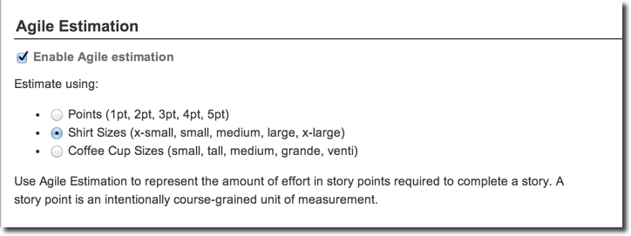

**Estimating with Different Units**

You use story points in the range of 0 to 5 to estimate the amount of work required to complete a story. The value 0 represents no estimate and the value 5 represents the maximum amount of effort.  
  
You can use different units to represent the story point values:

* Raw Points - The values 1pt, 2pt, 3pt, 4pt, 5pt
* Shirt Sizes - The values x-small, small, medium, large, x-large
* Coffee Cup Sizes - The values small, tall, medium, grande, venti

Picking different units is purely a matter of preference. If you enjoy saying that one story seems like a grande story then you should use Coffee Cup Sizes. If it seems more natural to say that a story feels like an x-small then use Shirt Sizes.  
  
You can switch among different units at any time. Internally, SonicAgile stores Agile estimates as raw points between 0 and 5.

**Assigning Agile Estimates**

You can assign an Agile estimate to a story when you first create a story or when you edit a story.  
  
﻿You also can assign an Agile estimate to one or more stories from the Backlog toolbar. Select one or more stories with your mouse (you can use the SHIFT or CTRL keys to select multiple stories) and assign an Agile estimate.

**Agile Estimation and Burndown Charts**

After you enable Agile estimation, you can view a Burndown Chart that charts how work burns down over time. The chart displays the sum of the points in all open stories over time.  When you close a story, the points are subtracted from the remaining work.  
  
If you enable Iterations then the Burndown Chart displays remaining work for a particular iteration. Otherwise, the Burndown Chart displays the remaining work for all of the stories in your project.

**Agile Estimation and Velocity**

If you enable iterations then you can view the sum of the story points contained in each iteration. This value appears in the Backlog at the top of each iteration.    
  
Knowing the number of points completed in previous iterations enables you to track your team's velocity. Your team's velocity is the average number of points completed in past iterations. You want your team's velocity to improve over time.

**Too Much Work Warning**

You can use Agile estimation to help you know when you are attempting to do too much work in an iteration.  
  
If you add too much work to an iteration then SonicAgile will display a warning icon. This warning icon appears in your backlog at the top of an iteration.  
  
The "too much work" warning appears when the sum of the story points in an iteration is greater than the average of the past 3 iterations (a warning will only be shown if there is at least 3 previous iterations).

# Attaching Files to Stories and Epics

You can upload files and attach the files to stories and epics. Attaching a file to a story or epic makes it easy to share a file with members of your project.  
  
Imagine, for example, that you need to complete the story "Update Website Logo". In that case, attaching the new website logo image to the story would be very useful. You also can attach other types of files such as Microsoft Word documents, videos, and Excel Spreadsheets to a story or epic.

## Connecting to Dropbox

Before you can use SonicAgile with Dropbox, the project owner must first create a Dropbox account. You can create a free Dropbox account that includes 2 Gigabytes of storage by visiting Dropbox.com:  
  
[http://Dropbox.com](http://dropbox.com/)  
  
After you create a Dropbox account, you must connect your SonicAgile project to Dropbox. You only need to do this once for each of your projects. Follow these steps:  
  
1. Click **Settings** to navigate to Project Settings  
  
2. Select the **Files** tab  
  
3. Click the link labeled **connect**  
  
Sign in to Dropbox and authorize SonicAgile to connect to Dropbox. After you complete these steps, a new folder located at Apps\SonicAgile will be added to your Dropbox. All of the files uploaded to SonicAgile will be stored in this folder.

## Adding Files to a Story or Epic

After the project owner has connected a project to Dropbox, any member of the project can add files to stories or epics.  Follow these steps to a add a file to a story:  
  
1. Double-click the story on the Backlog or Kanban  
  
2. Select the **Files** tab (on the right-hand side of the screen)  
  
3. Click the **upload file** button to upload a new file  
  
After you upload a file, any member of the project can download the file by clicking the name of the file under the Files tab.  
  
If you need to upload multiple files at the same time then you can hold the SHIFT key or CTRL key when selecting files. The files will be uploaded in a batch.

## Security Considerations

After the project owner connects their SonicAgile project to Dropbox, any member of the project can add, view, and delete any file in the project owner's Apps\SonicAgile Dropbox folder. For example, a member of the project could go insane and decide to delete all of the project files from the Apps\SonicAgile folder.  
  
Furthermore, if a project owner connects more than one project to the same Dropbox account, then the members of one project can access the files from another project (This would take some work, but it is possible). If you want to isolate the files from different projects then you need to connect the projects to different Dropbox accounts.  
  
However, a member of SonicAgile cannot access any folder in the Dropbox account outside of the Apps\SonicAgile folder. Dropbox limits access to only that folder and no other folder. Every SonicAgile project is added as a subfolder beneath the Apps\SonicAgile folder.

**Using the SonicAgile Real-Time Backlog**

Use the SonicAgile Real-Time Backlog to create a prioritized list of all of the work that you need to get done. The Backlog contains a list of all of your stories. The most important stories should appear at the top of the list and the least important stories should appear at the bottom of the list.  
  
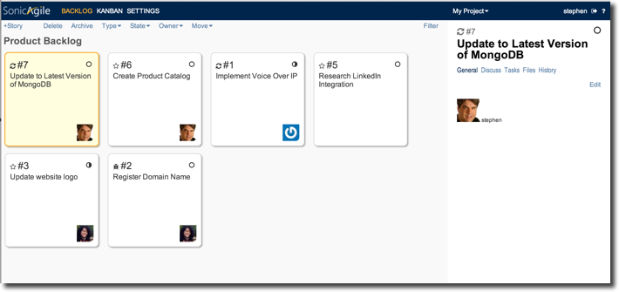

**Real-Time Backlog**

The SonicAgile Backlog takes advantage of the real-time web. When multiple people are viewing the backlog at the same time, and anyone makes changes to the Backlog, then everyone sees the changes in real-time. For example, if you change the position of a story, or change the state of a story from *In Progress* to *Done*, then these changes appear in everyone's browser in real-time.  
  
This is a great feature for distributed teams. While discussing changes to your Backlog with your team over Skype, you can make changes to your Backlog and everyone will see those changes without refreshing their browsers.   
  
This is also a great feature even when everyone in your team is seated in the same conference room. When anyone makes a change the Backlog, everyone else sees the change almost instantly.

**Adding Stories to the Backlog**

You add a new story to the Backlog by clicking the +Story button. When you create a new story, you are required to enter values for the following two properties:

* **Title** - The story title should be kept brief. For example, "Create a shopping cart" or "Update website logo"
* **Type** - The default story types are Feature, Bug, or Change. For example, "Create a shopping cart" might be a new Feature.  (You can customize the story types in Project Settings).

A story also has several optional properties:

* **Owner** - The person who is currently responsible for completing the story.
* **State** - The state of the story - *To Do*, *In Progress*, or *Done*.
* **Iteration** - The iteration associated with the story. The project owner must enable Iterations for this property to appear.
* **Agile Estimation** - The amount of work estimated to complete the story. The project owner must enable Agile Estimation for this property to appear.
* **Time Tracking** - The Original Estimate, Time Spent, and Time Left for the story. The project owner must enable Time Tracking for this property to appear.
* **Tags** - A comma separated list of tags. Use these tags when filtering stories.
* **Description** - The full description of the story. You can enter rich text into the description.

When you add a new story, the story appears at the top of your Backlog.

**Viewing Story Details**

You can view the details for any story on your Backlog by double-clicking the story.  The story panel opens on the right-hand side of your screen.    
  
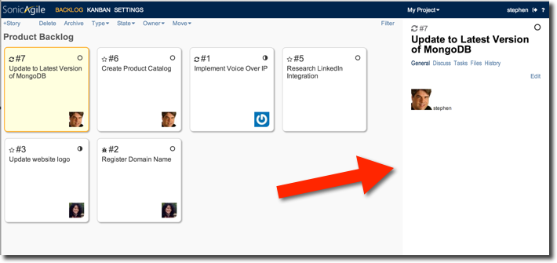  
The Story panel contains several tabs:

* **General** - Displays story properties such as the story owner and story description.
* **Discuss** - Displays discussion messages associated with the story (including any email discussion).
* **History** - Displays the history of changes to the story.
* **Acceptance** (optional) - Displays Acceptance Criteria for the story. This tab appears only when you enable Acceptance Criteria in Project Settings.
* **Files** (optional) - Displays Files associated with the story. This tab appears only when you connect to Dropbox in Project Settings.

**Moving Story Cards on the Backlog**

You can move stories on the Backlog with your mouse. Simply drag a story from one location on the Backlog onto a new location. When you drag a story on top of another story, an orange border appears on either the left or right edge of the story that indicates where the story will be dropped.  
  
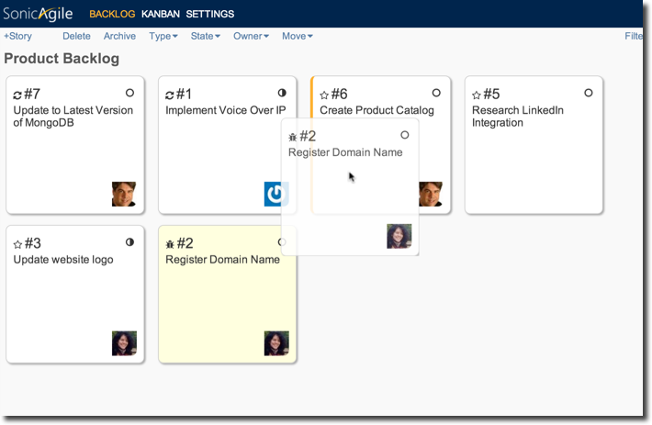  
  
If you have enabled iterations then you can also drag a story back and forth between the Backlog and individual iterations.  
  
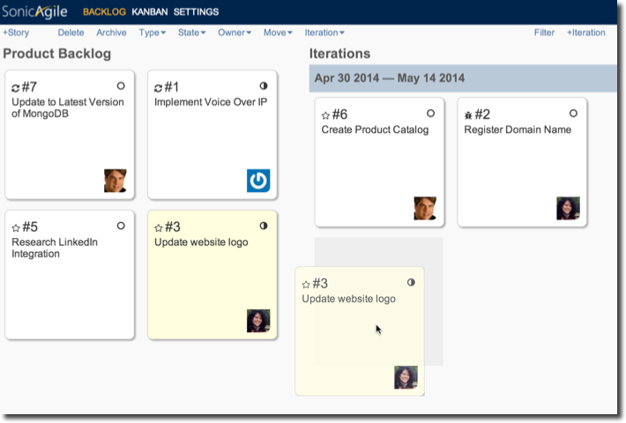

**Moving Multiple Stories on the Backlog**

You can drag and drop multiple stories on the Backlog. Click a story, hold down the SHIFT key, and click another story to select a range of stories. Click a story, hold down the CTRL key, and click one or more stories to select multiple stories not in a range. After you select multiple stories, you can drag the stories as a group.  
  
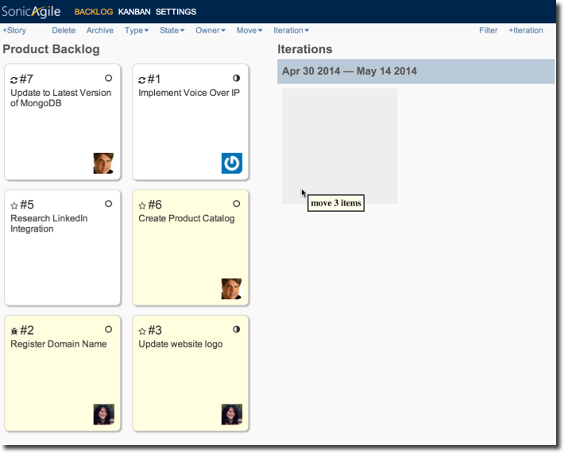

**Using the Backlog Toolbar**

You can change the properties of a story by using the Backlog toolbar. For example, you can change the state of a story from *In Progress* to *Done* by using the toolbar. You can also use the toolbar to move stories in the Backlog.  
  
You can use the toolbar to change the properties of multiple stories at once. Use the SHIFT key or the CTRL key to select multiple stories and then use the toolbar to change a property of the stories.  
  
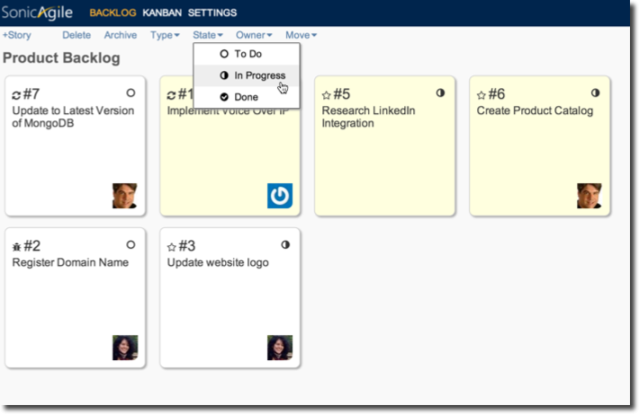

**Archiving Stories**

You can archive stories in the Backlog. After you archive a story, the story no longer appears in the Backlog. To see the story again, you must click the Filter toolbar link.   
  
Archiving stories is useful after you mark a story as done. When a story is done, you can archive the story and focus on the next uncompleted story.  
  
You cannot archive a story in an iteration. You can archive only those stories that appear in the Backlog.

**Adding Iterations to the Backlog**

Iterations is an optional feature of SonicAgile that can be enabled by the project owner. If you enable iterations, then you can group the stories in the Backlog into different iterations.   
  
For example, your team might work in 2-week iterations. In that case, before you begin an iteration, you would first choose a set of stories from the Backlog and add the stories to the iteration.

# Using Time Tracking with SonicAgile

After you enable time tracking, you can track how much time it takes to complete each story. You can track the Original Estimate, the Time Spent, and the Time Left for each story.  
  
Enabling time track is useful in two situations. First, when working with a client, you might need to accurately track the amount of time that you devote to each story so you can accurately bill the client.  
  
Second, you might want to be alerted when a story is taking too long to complete (when a story goes overtime). If you have gone over the original estimate then you might need to devote more resources to the story.

## Enabling Time Tracking

Time tracking is disabled by default. The owner of a project (the person who created the project) can enable time tracking under Project Settings. Follow these steps:  
  
1. Click the **Settings** link.  
  
2. Click the **Stories** tab.  
  
3. Check the checkbox labeled **Enable Time Tracking**. 

## Using Time Tracking

When you create a new story, you can enter the Original Estimate for how long you think it will take to complete the story.  The Original Estimate for the story becomes the Time Left for the story automatically when you save the new story.  
  
During your daily standup meeting, your team can update the Time Spent and Time Left for each story on the Kanban. Each day, the Time Spent and Time Left for each story might change.  
  
Imagine, for example, that your team is working on the story "Create a Shopping Cart". When you first create the story, you might enter an Original Estimate of 4 days. However, on day 3, you might realize that the story is going to take longer than you originally estimated. On day 3, you might enter the value 3 for Time Spent and the value 2 for Time Left.  In other words, by day 3, you realize that the story will take 1 more day than you originally estimated.  
  
It is normal for the Time Left estimate to get more and more accurate as more work is done on a story. For this reason, you enter the Time Spent and Time Left as independent values when using SonicAgile.   

## Knowing when a Story is Overtime

When the Time Spent on a story goes over the Original Estimate for the story then an icon appears on the story card alerting you that the story has gone overtime. An icon of a clock appears in the top-right corner of the story.  
  
If you believe your Original Estimate was inaccurate  (you entered it while in a fit of optimism)﻿ then you can modify your Original Estimate by editing the story. This gives you a way to make the overtime clock go away.  
 

## Time Tracking and Tasks

Tasks is another optional feature of SonicAgile. After you enable Tasks then you can break stories into multiple tasks.  
  
You can use time tracking with both stories and tasks. Until a story is broken into tasks, the Time Spent and Time Left is tracked for the story. As soon as you break the story into tasks then the Time Spent and Time Left is rolled up from the Time Spent and Time Left for each task.  
  
You can't edit the Time Left and Time Spent for a story that has been broken into tasks. After a story has been broken into tasks, you must edit the Time Left and Time Spent for the tasks associated with the story instead.  
  
The Original Estimate for a story, on the other hand, is not rolled up from its tasks. If you originally estimated that a story would take 2 days, but the sum of the Time Left for the tasks associated with the story is 5 days, then you will see an overtime warning on the story.

## Estimating using Hours or Days

When you enable time tracking in Project Settings, you can choose to track time using either hours or days. This is purely a matter of preference. If you are tracking time at the level of tasks then you might want to use hours. If you are tracking time at the level of stories then you might want to use days. Again, this is entirely a matter of preference.  
  
You can switch back and forth between hours and days whenever you want. Internally, SonicAgile tracks everything using hours. If you switch to using days, SonicAgile simply transforms the hours into days when displaying the time values.  
  
You can set the number of hours in a day. By default, SonicAgile assumes that there is 8 hours in a day. The number of hours in a day is used when converting back and forth between the internal representation of time in hours.

# A Guide to using SonicAgile for Agile Teams

Imagine that you need to manage a complex project. You need to coordinate a team of people to get work done. SonicAgile can help!

SonicAgile is a free Agile Project Management tool. You can use SonicAgile to capture all of the work required to complete a project, prioritize the work, and track your progress as the work gets done.

SonicAgile was expressly designed to support Agile teams. For example, you can use SonicAgile with a Scrum team or a team that is following the best-practices of the PMI-ACP.

The goal of this guide is to provide you with an overview of the major features of SonicAgile. You learn how to take advantage of the SonicAgile Backlog, Kanban, and Burndown Charts.

## Prioritizing Work

The first thing that you need to do when starting a new project is to create a list of all of the work that needs to be done. For example, if you are building a new e-commerce website then you might need to register a domain name, create a shopping cart, and create a catalog of products.

SonicAgile is designed to be an Agile Project Management tool. For this reason, it uses Agile terminology to describe the work that needs to be done. In particular, each work item, such as registering a domain name or creating a shopping cart, is called a story. The list of all of the stories that need to be completed to finish a project is called a Product Backlog.

You can think of your Product Backlog as a giant To Do list. You use your Product Backlog to list all of the work (each story) that needs to be done.

Immediately after you register at SonicAgile.com, you land in your backlog. You add new stories to your backlog by clicking the +Story button.

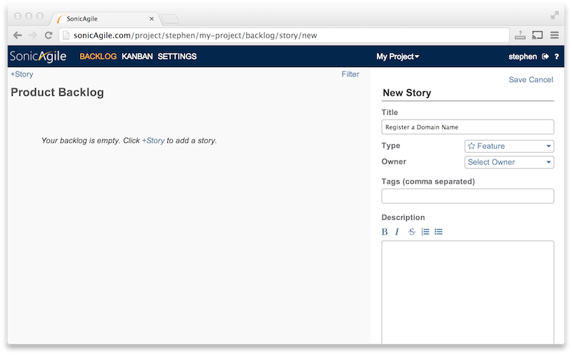

When you create a new story, you must enter a story title and story type. For example, you might enter the story title “Register a domain name” and the story type “feature”. All of the other fields are optional.

The SonicAgile backlog is a real-time backlog. When you make changes to the backlog, everyone else in the world who has the backlog open in their browser will see the changes immediately.

### Moving Stories on the Backlog

Your Product Backlog represents a prioritized list of work that needs to be done. You list the most important work at the top of your backlog and the least important work at the bottom of your backlog.

SonicAgile makes it easy to rearrange the stories in your backlog. You can drag any story in your backlog from one location to another using your mouse.

You also can select and move multiple stories at a time by holding down either the SHIFT key or the CTRL key when clicking on stories with your mouse. Use the SHIFT key to select multiple stories in a range. Use the CTRL key to select multiple stories individually.

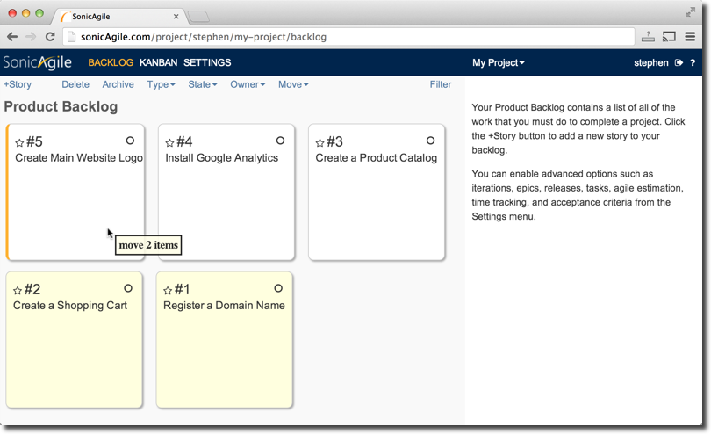

Because the SonicAgile backlog is a real-time backlog, moving a story in one browser causes the story to move in every other browser where the backlog is open.

### Dividing Work into Iterations

Many Agile teams like to work in iterations (also called sprints). For example, many Agile teams work in two-week iterations. At the beginning of each iteration, the team selects a set of stories from the backlog that they want to get done and then the team attempts to get all of the stories done before the end of the iteration.

Iterations are an optional feature of SonicAgile. You can enable iterations from your Project Settings under the Stories tab.

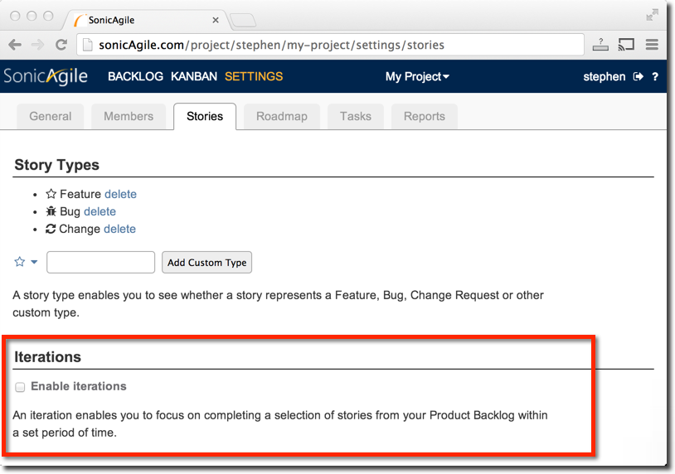

After you enable iterations, you can add new iterations to your backlog by clicking the +Iteration button. When you add an iteration, you specify the start and end date of the iteration.

After you enable iterations, your backlog is divided in half. The left column of your backlog represents your Product Backlog and the right column represents your iterations. You can drag stories from your Product Backlog into any of the iterations that you have created. Copy multiple stories into an iteration by using either the SHIFT or CTRL key to select multiple stories and drag the stories into an iteration.

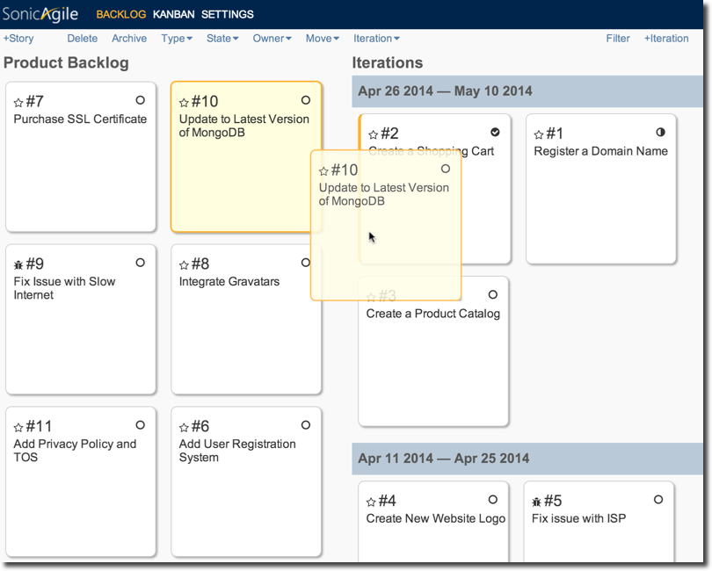

### Using Agile Estimation

When prioritizing the stories in your Product Backlog, it helps to know the amount of work required to complete each story. Some stories might be relatively easy to complete while other stories might require a lot of work. For example, registering a domain name might take less than an hour but building a shopping cart component might require several weeks of effort.

The traditional way of estimating work is to create an estimate based on the amount of time that you predict will be required to complete the work. For example, a little story might require an hour or two and a big story might require many days or weeks to complete.

Proponents of Agile project management typically reject estimating the amount of work required to complete a story by using hours or days. The problem with time-based estimates is that they provide an illusion of accuracy when the estimates are really just a best guess.

Instead, Agile teams typically use another unit of estimation such as points or shirt sizes. For example, when using shirt sizes, you might estimate stories as being x-small, small, medium, large, or x-large. There is no illusion of accuracy when you are limited to only five possible values when making an estimate. Asserting that registering a domain name is an x-small story is much more accurate than asserting that registering a domain name will take exactly 1 hour.

Agile Estimation is an optional feature of SonicAgile. You enable Agile Estimation from your Project Settings. You can estimate using points, shirt sizes, or (my favorite) coffee cup sizes.

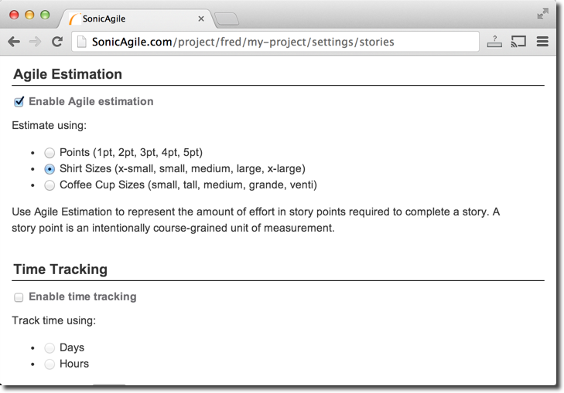

After you enable Agile Estimation, you can assign an estimate to any story in your backlog. Select the story in your backlog and select a size from the backlog toolbar.

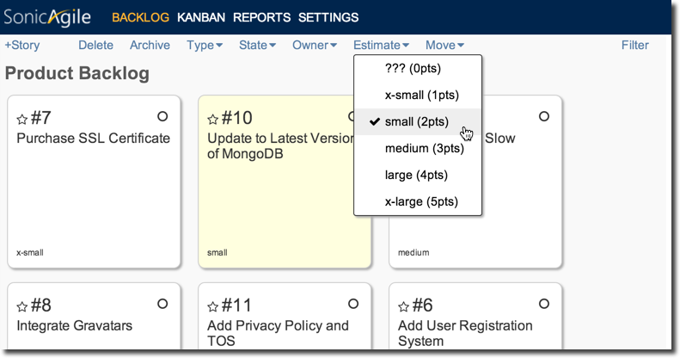

If you enable both Agile Estimation and iterations then you can track your team’s velocity. Each iteration will display the total number of story points completed in the iteration. If you attempt to add too many stories to an iteration – more than the average of the past three iterations – then a warning is displayed.

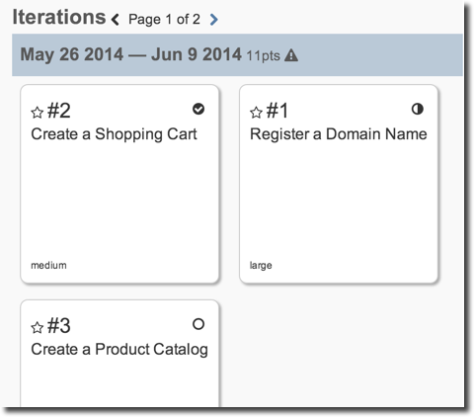

Finally, if you enable Agile Estimation, then you can view a Burndown Chart that represents your team’s progress. A Burndown Chart displays the amount of work (represented in story points) remaining over time.

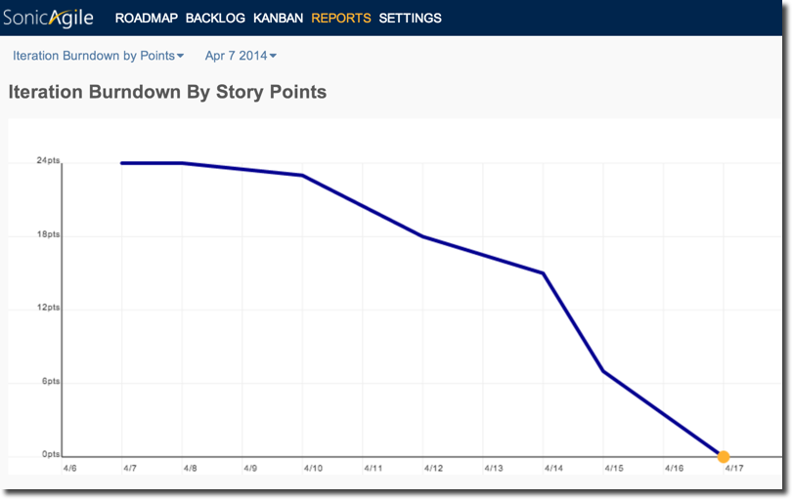

### Creating a Roadmap with Epics and Releases

SonicAgile enables you to create a roadmap for your project. A roadmap contains a list of epics organized into releases. You can use the roadmap to create a release plan for your project.

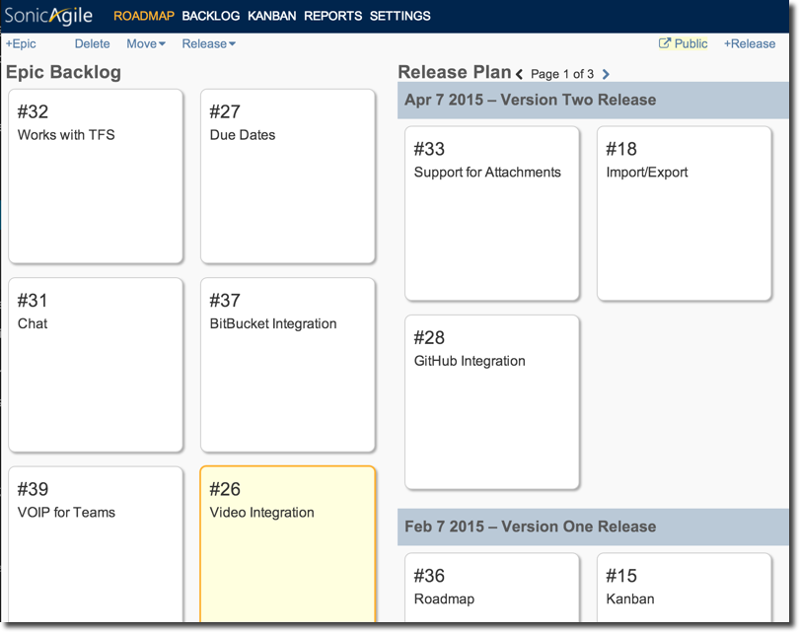

Imagine, for example, that you want to decide which features to add to version one and version two of your product. In that case, you can create two releases named version one and version two.

Next, you can create epics that correspond to the major features of your product and decide which release should include each epic. For example, you might decide that the Jet Engine won’t be included in version one of your product but it will be included in version two.

You also have the option of making your roadmap public. In that case, anyone in the world can see your roadmap and the description for each epic in your roadmap. Members of the public can even vote and comment on the epics in your roadmap.

## Tracking Team Progress

SonicAgile enables you to easily keep track of work on a project. You can track who is working on each story and you can track the state of each story by taking advantage of the SonicAgile Kanban.

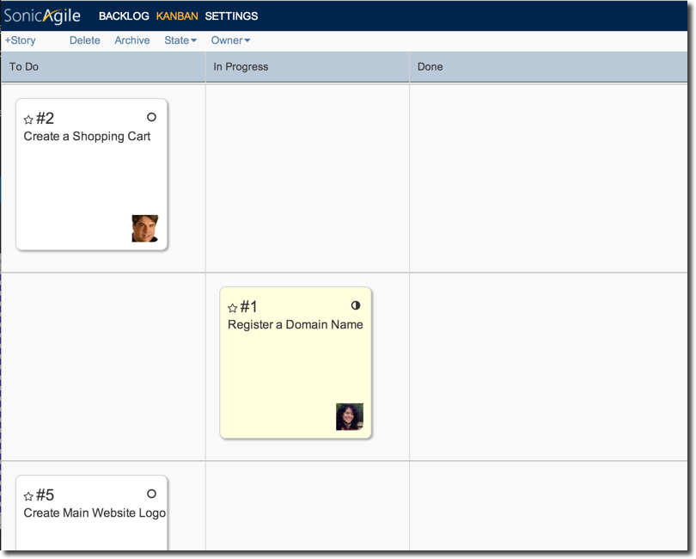

The Kanban represents an alternative view of your backlog. The Kanban displays the stories from your backlog in order of priority. Each story is displayed in one of three columns: To Do, In Progress, or Done.

You can use your mouse to drag stories from one column to another. For example, when a story is done, you can move the story from the In Progress column to the Done column.

After a story is done, you can click the Archive button to remove the story from your Kanban. That way, the highest priority stories will always be at the top of your backlog.

Because the SonicAgile Kanban is a real-time Kanban, when the Kanban is open in multiple browsers, changes made to the Kanban in one browser are reflected in every other browser automatically.

### Using Iterations

If you enable iterations then the SonicAgile Kanban will display only the stories from the current iteration. You can use the iteration dropdown list to view past or future iterations.

When you enable iterations, the Archive button no longer appears. If you are grouping stories into iterations then you no longer need to archive stories when you complete a story.

### Breaking Stories into Tasks

You can break stories into tasks. Tasks appear beneath their story in the Kanban. Just like a story, you can move a task from To Do, to In Progress, to Done.

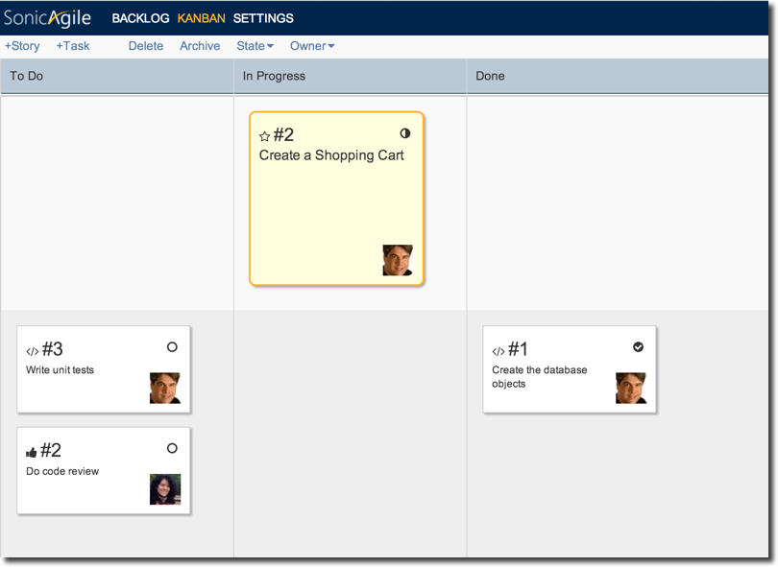

There are several reasons why you might want to break a story into tasks. First, if you discover that a story is taking much longer than expected to complete (the story is becoming a never ending story) then you might want to break the story into discrete tasks so you can better track progress on completing the story.

For example, imagine that the story “Create a Shopping Cart” has remained in the In Progress column in your Kanban for several weeks. In that case, you might want to break the “Create a Shopping Cart” story into several discrete tasks such as “Create the Database Objects for the Shopping Cart”, “Implement the Code for the Shopping Cart”, and so on. That way, you can better track progress completing the overall story by tracking when each task associated with the story is completed.

A second situation in which it makes sense to enable tasks is when you need to ensure that certain work is completed before a story is done. For example, you might want to ensure that each story gets tested and reviewed before the story is marked as done. In that case, you can create separate Test and Review tasks for each story and ensure that both of these tasks are done before the story is marked as done.

Tasks are an optional feature of SonicAgile. You enable Tasks from Project Settings.

After you enable Tasks, you can add a task on the Kanban by selecting a story and clicking the +Task button. You must select a story on the Kanban before you can add a Task to that story.

### Using Time Tracking

You can enable Time Tracking to track the time spent and time left for each of your stories. You can also use Time Tracking to quickly identify when you have devoted more time to a story than you originally expected.

When you create a new story, you can enter an original estimate for the amount of time that you expect it to take to complete the story. During your daily standup meeting, you can update the time estimates for each story by entering estimates for the time left and time spent. The story displays a progress bar that indicates the estimated amount of time left to complete the story.

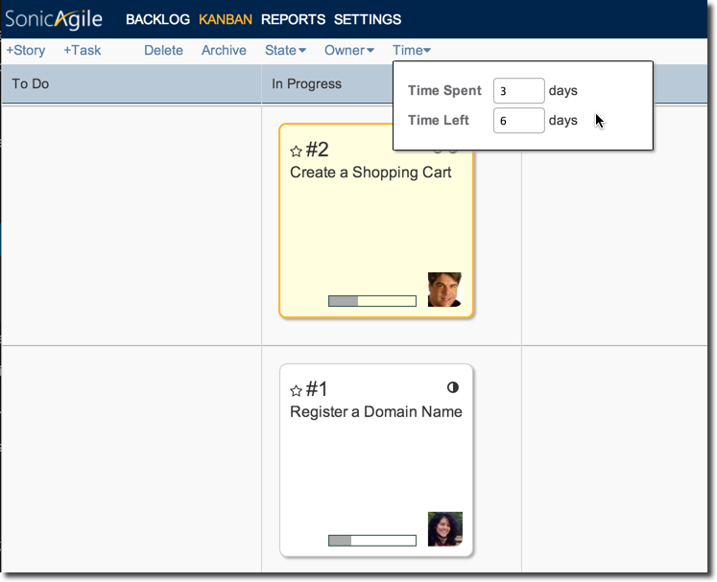

If the time spent on a story goes over the original estimate then a warning icon is displayed.

If you enable both Time Tracking and Tasks then you can use Time Tracking with tasks. In that case, the time spent and time left for each story is rolled up from the time spent and time left for each task associated with a story.

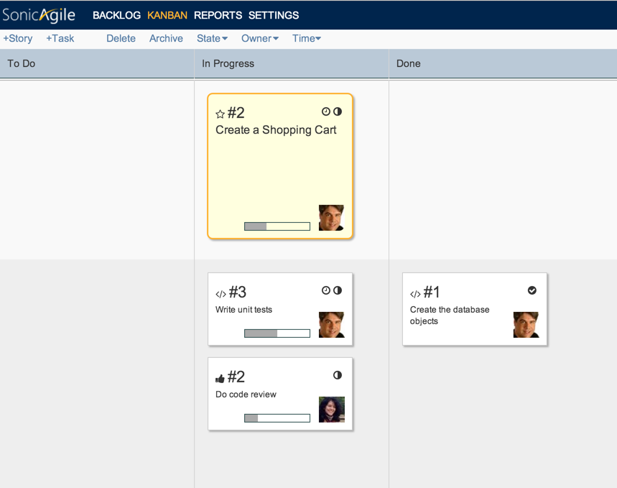

Time Tracking is an optional feature. You enable Time Tracking from the Stories tab in Project Settings. You can track time using either hours or days.

### Using Acceptance Criteria

You can add one or more acceptance criteria to any story. Acceptance criteria represent a checklist of requirements that a story must satisfy in order for the story to be done.

Acceptance criteria can be anything that you want. For example, if you are building a software component then you might create a list of acceptance criteria that looks like this:

• Must work with the most recent version of all web browsers  
• Must include at least 5 unit tests  
• Must be reviewed by the open-source team for legal compliance

If you attempt to mark a story as done with unsatisfied acceptance criteria then you get a warning message.

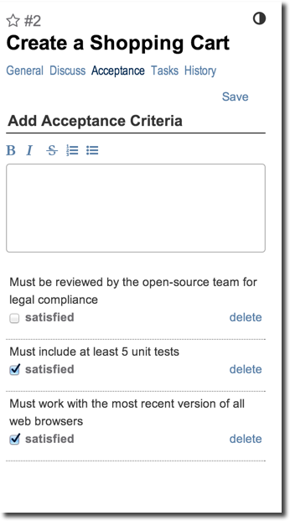

## Improving Team Collaboration

Members of your team can take advantage of SonicAgile without even visiting the SonicAgile.com website. You can interact with SonicAgile through email. You can receive notifications and reports, participate in discussions, and create new stories without leaving your email inbox.

### Notifications

By default, every member of your team receives an email notification whenever a new story or epic is created or a story is marked as done. Each member of your team can control their email notifications from their Profile Settings.

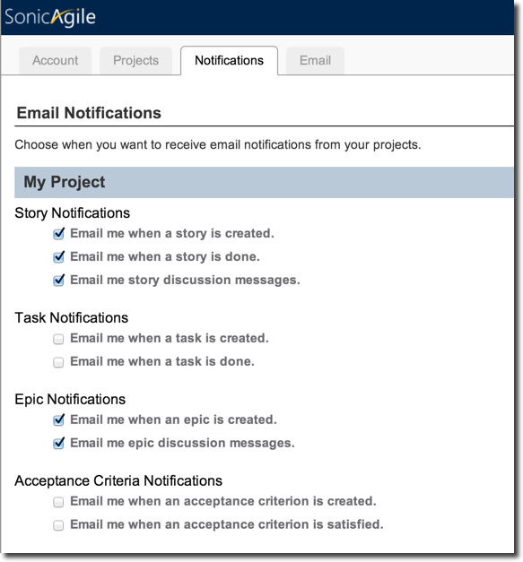

### Story and Epic Discussion

Members of your project can discuss stories and epics through email by replying to a new story notification or by replying to another discussion message. All email discussions are captured automatically at SonicAgile. That way, new team members can get quickly up to speed on existing stories and you don’t lose valuable discussions in the depths of your email inbox.

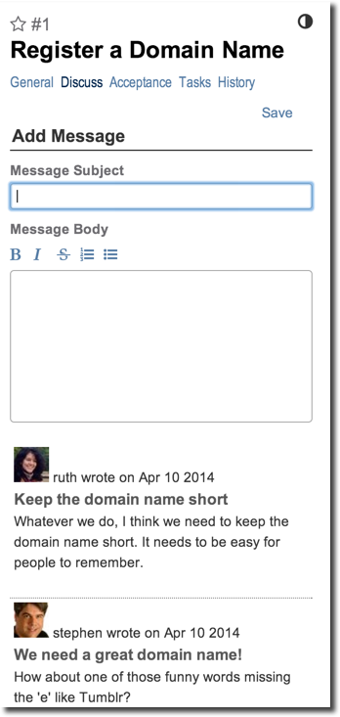

### Create Stories by Email

You can create new stories directly from email by emailing to a magic email address. For example, you can create new features, bugs, or change requests by sending an email message to the right email address.

Creating stories by email enables you to create new stories from a smart phone. For example, while walking through the park, you can create a new bug at SonicAgile by sending an email from your iPhone.

The magic email addresses are listed in your Profile Settings.

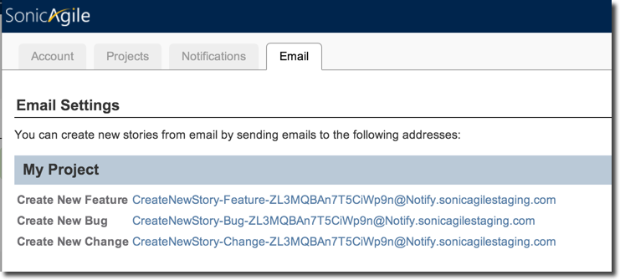

### Scheduled Reports

You can email scheduled reports to the members of your team automatically. The scheduled reports contain one or more Burndown Charts.

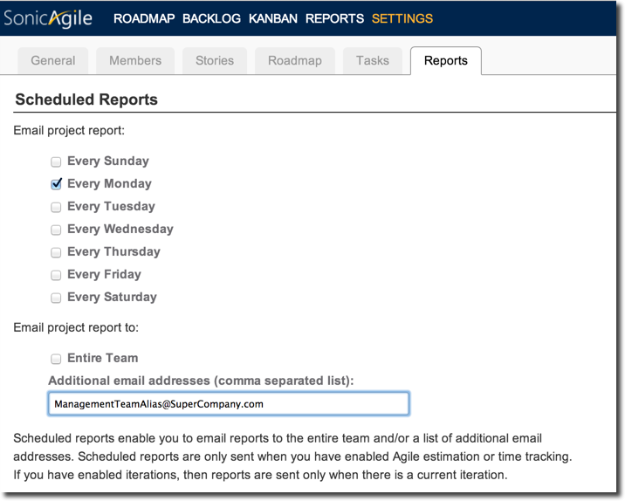

You also can send scheduled reports to people outside of your team. For example, you might want to send a weekly scheduled report to management to report on progress on your project.

## Conclusion

SonicAgile is a free Agile Project Management tool that enables you to coordinate the work of a team of people. The tool was designed to be easy to use and very flexible. SonicAgile supports several unique features such as a real-time backlog and Kanban, Agile estimation, acceptance criteria, time-tracking, epics, tasks, iterations, stories by email, email notifications, burndown charts and private and public roadmaps.

# A Guide to using SonicAgile for Managers

Managing a project is like driving a train up a very steep mountain on slippery tracks while being attacked by giant eagles. In other words, managing a project is *hard*.

There are so many things that can throw a project off track including:

* **Scope Creep** – More and more requirements being heaped on a project over time.
* **Insufficient Resources** – Even if your team is composed of super heroes (Batman, Wonder Woman, the Flash), there are just not enough hours in the day to complete all of the planned work.
* **Insufficient Communication** – The Product Owner expects you to build a refrigerator and you build a coffee maker.
* **Wrong Priorities** – Low priority features get all of the love and attention while high priority features are ignored.
* **Low Quality** – Work gets done, and then it needs to be redone, and then redone, and then redone, ad nauseam.

SonicAgile is a tool that is designed to support the needs of both the members of Agile teams and the managers who are responsible for the Agile teams. The tool has two websites:

* **SonicAgile.com** – SonicAgile is designed for Agile teams. SonicAgile includes a backlog, kanban, and burndown charts. The tool is designed to be as simple as possible (otherwise, Agile teams won’t use it).
* **SonicAgileInsights.com** – SonicAgile Insights is designed for managers. SonicAgile Insights includes a dashboard and cross-project reports. This tool has all of the features required for enterprise project management.

This guide focuses on SonicAgile Insights. You learn about the features of SonicAgile for managing Agile Teams.

## Agile Portfolio Management

Most managers need to manage multiple projects at the same time. In other words, most managers are responsible for overseeing a *portfolio* of projects.

SonicAgile supports *Agile Portfolio Management*. Adding multiple projects to the same portfolio enables you to take advantage of the SonicAgile dashboard and enables you to generate cross-project reports.

Here are the steps for creating a new Portfolio:

1. If you don’t already have a SonicAgile account then register for a SonicAgile account at http://SonicAgile.com.
2. Using your SonicAgile username and password, login at http://SonicAgileInsights.com.

When you first login at SonicAgile Insights, a portfolio named “My Portfolio” is created for you. This portfolio contains all of the SonicAgile projects that you have permissions to view.

All of the SonicAgile projects that you own (that you created) are included in “My Portfolio” automatically. You can add SonicAgile projects that you don’t own to “My Portfolio” by asking the project owner to add you as a Portfolio Viewer. Follow these steps:

1. The SonicAgile project owner logs into their project at http://SonicAgile.com.
2. The project owner navigates to Project Settings by clicking the Settings link.
3. The project owner selects the Members tab.
4. The project owner adds you (the Portfolio Owner) as a Portfolio Viewer by entering either your username or email address.

[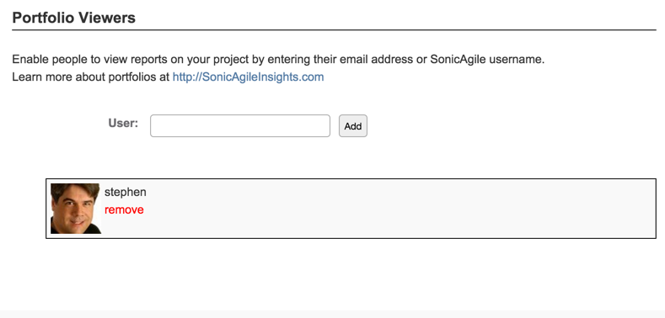](http://sonicagile.com/wp-content/uploads/2014/11/PortfolioViewers.png)

After you are added as a Portfolio Viewer to any SonicAgile project, even projects that you don’t own, you can view the project in your Portfolio dashboard and include the project in your cross-project reports.

## Agile Release Planning

Imagine that you need to plan the next release of a product. For example, you are planning the *Version Two* release of your product. In that case, you can take advantage of SonicAgile to perform Agile Release Planning.

There are several reasons to do Agile Release Planning:

* **Prioritize Features** – Create a high-level roadmap of the features that you want to include in your next product release and prioritize the features.
* **Resource Capacity Planning** – Ensure that you have enough resources to complete the features planned for the next product release.
* **Prioritize Projects** – Ensure that higher priority projects are receiving more resources than lower priority projects.

Agile Release Planning is all about planning the features that you want to include in your next product release and ensuring that you have the resources to implement the features. A release is typically something that is 6 months to 1 year in the future.

Here are the steps that you need to complete for Agile Release Planning:

1. Create a roadmap that contains the epics that you plan to complete in the release.
2. Break the epics into stories and estimate the amount of work required to complete each story.
3. Use SonicAgile Insights to view reports on the release plans.

Let’s examine each of these steps in detail.

### Create a Roadmap

When planning a release, you want to plan at the right level. You want to focus on the big features — the epics — that you want to include in the release.

You use the SonicAgile roadmap for release planning. The roadmap contains a list of epics organized into releases. When developing a release plan, you select the epics that you plan to complete in the release.

[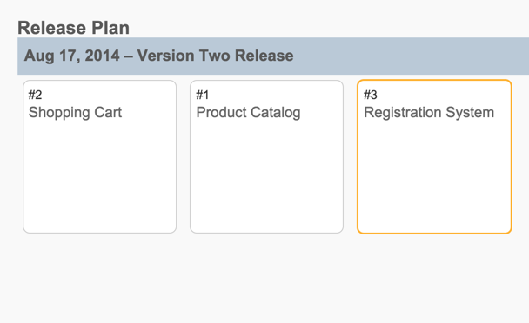](http://sonicagile.com/wp-content/uploads/2014/11/Roadmap.png)

The roadmap is not enabled by default. Follow these steps to enable the roadmap:

1. Login to your SonicAgile project at http://SonicAgile.com.
2. Click Settings to navigate to your project settings.
3. Select the Roadmap tab.
4. Check the checkbox labeled *Enable roadmap*.

After you complete these steps, a new menu item labeled Roadmap appears in your SonicAgile project.

After you enable the roadmap, you can create a release:

1. Login to your SonicAgile project at http://SonicAgile.com.
2. Navigate to the Roadmap by clicking the Roadmap link.
3. Click the +Release button to open the New Release dialog.
4. Enter a name, start date, and end date for the new release.
5. Click the Save button to create the new release.

After you create a release, you can create one or more epics and add the epics to the release. Follow these steps to create an epic:

1. Login to your SonicAgile project at http://SonicAgile.com.
2. Navigate to the Roadmap by clicking the Roadmap link.
3. Click the +Epic button to open the New Epic dialog.
4. Enter a title and description for the epic.
5. Click the Save button to create the new epic.

[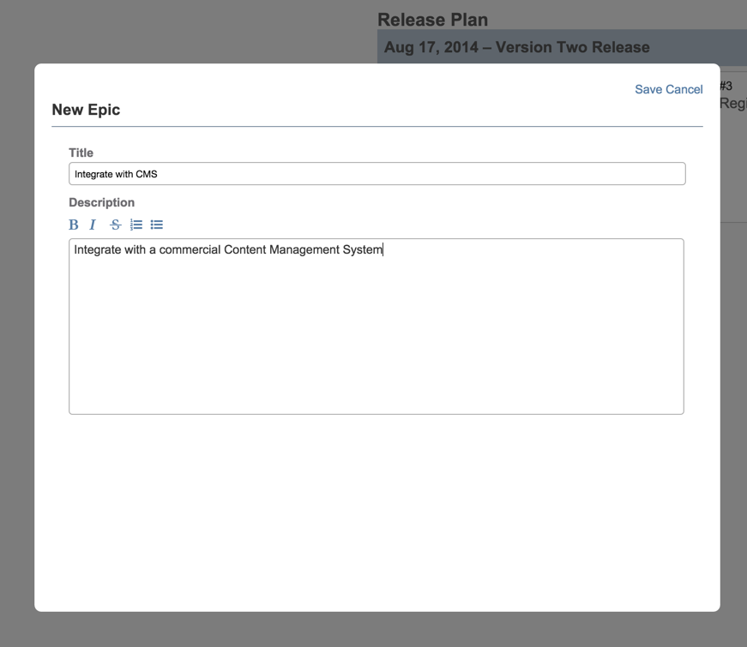](http://sonicagile.com/wp-content/uploads/2014/11/NewEpic.png)

After you create an epic, you can drag the epic into the new release.

### Break Epics into Stories

You don’t estimate at the level of epics, you estimate at the level of stories. As part of creating a release plan, you must break your epics into stories and estimate the amount of time that it will take to complete each story.

You must enable Time Tracking before you can provide time estimates for stories. Follow these steps:

1. Login to your SonicAgile project at http://SonicAgile.com.
2. Navigate to Project Settings by clicking the Settings link.
3. Select the Stories tab.
4. Check the checkbox labeled *Enable Time Tracking*.

After you enable Time Tracking, you can enter time estimates for each of the stories that you create.

[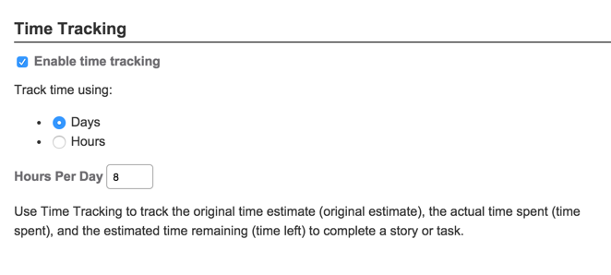](http://sonicagile.com/wp-content/uploads/2014/11/TimeTracking1.png)

Follow these steps to create a story, enter an original time estimate for the story, and associate the story with an epic:

1. Login to your SonicAgile project at http://SonicAgile.com.
2. Navigate to the Backlog by clicking the Backlog link.
3. Click the +Story button to open the New Story dialog.
4. Enter a title for the new story, an original time estimate for the story, and associate the story with a particular epic.
5. Click the Save button to create the new story.

Time estimates for stories roll up to their associated epics. When you open an epic on the Roadmap, you can view the sum of estimates for the stories associated with the epic.

[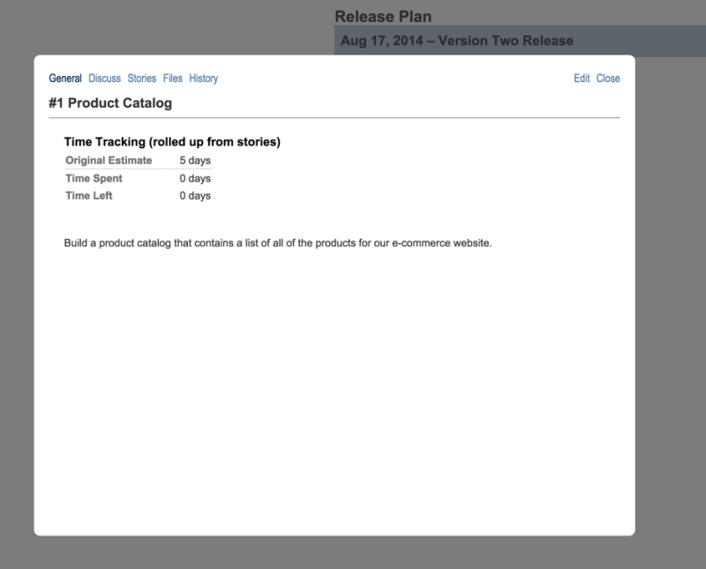](http://sonicagile.com/wp-content/uploads/2014/11/Epic-e1417444486268.png)

### SonicAgile Insights Agile Release Plan Reports

After you add a set of epics to a release, and you break the epics into stories, and you estimate the time required to complete each story, you can use SonicAgile Insights to help plan the release.

There are two reports that you can use for Agile Release Planning. First, you can use the*Release Plan by Epic* report to view a list of all of the epics planned for a release and the estimated time required for each epic.

[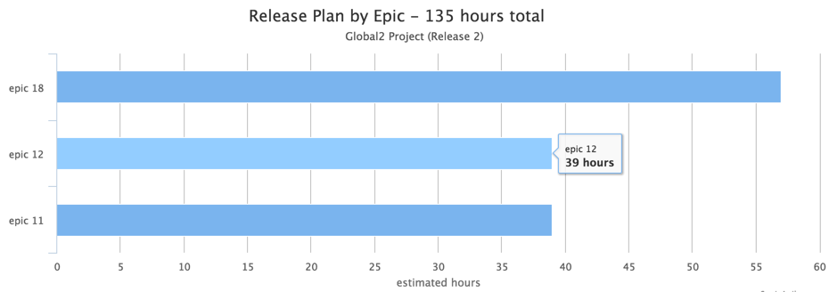](http://sonicagile.com/wp-content/uploads/2014/11/ReleasePlanByEpic.png)

You can use the *Release Plan by Epic* report, for example, during a release planning meeting to discuss whether or not the right epics are being included in a release and the priority of each epic.

Second, you can use the *Release Plan by Project* report to compare the total amount of planned work for each project in your portfolio. You can use this report to determine whether you are planning to devote too much or too little time to each of the projects in your portfolio.

[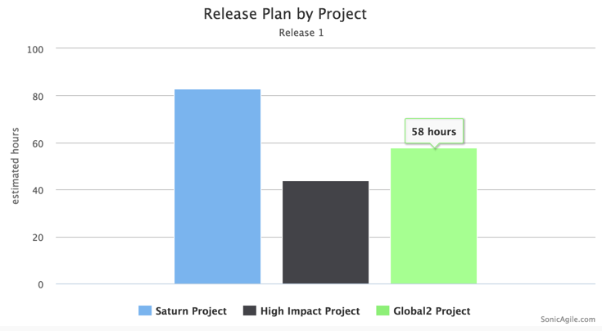](http://sonicagile.com/wp-content/uploads/2014/11/ReleasePlanByProject1.png)

## Agile Iteration Planning

Even if you don’t use Agile Release Planning, you should take advantage of Agile Iteration Planning. An Agile Iteration Plan is the plan for the next product iteration. Typically, a product iteration is 2 weeks to 1 month in the future.

Iteration planning is an essential part of Agile Project Management. During an Iteration Planning meeting with the Development Team, you select the stories that you plan to implement during the next iteration, you prioritize the stories, and you ensure that you have sufficient resources to complete the stories.

Typically you don’t create all the iterations up front. You create an iteration just before it begins.

There are three steps for planning an iteration:

1. Create the new iteration in your Backlog.
2. Add all of the stories that you plan to complete to the iteration.
3. Use SonicAgile Insights to help plan the iteration during the iteration planning meeting.

Let’s walkthrough each of these steps.

### Create the New Iteration

Iterations are an optional feature of SonicAgile. You can enable iterations by following these steps:

1. Login to http://SonicAgile.com.
2. Navigate to Project Settings by clicking the Settings link.
3. Select the Stories tab.
4. Check the checkbox labeled *Enable Iterations*.

After you enable iterations, you can add a new iteration to your backlog. Follow these steps:

1. Navigate to your Backlog by clicking the Backlog link.
2. Click the +Iteration button.
3. Enter a start date and end date for your new iteration.
4. Click the Save button to create the iteration.

After you create the iteration, you can drag one or more stories into the iteration.

[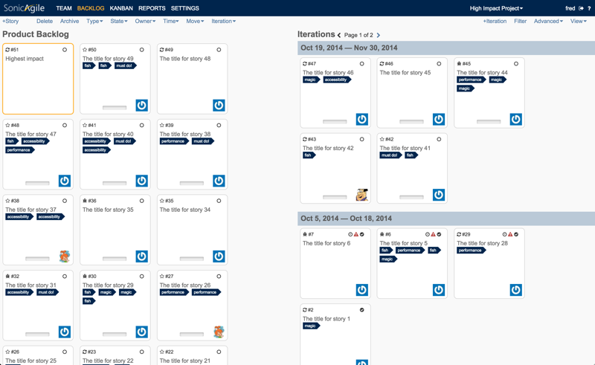](http://sonicagile.com/wp-content/uploads/2014/11/BacklogWithIterations.png)

### Story Owners and Time Estimates

When doing iteration planning, you should provide original time estimates for each of the stories in the iteration. You can enter an original time estimate for a story when you first create the story. You can modify the original time estimate when editing the story.

During the iteration planning meeting, you also should assign owners to each of the stories in the iteration. The easiest way to assign owners to a story is to use the owner dropdown list on either the Backlog or Kanban.

[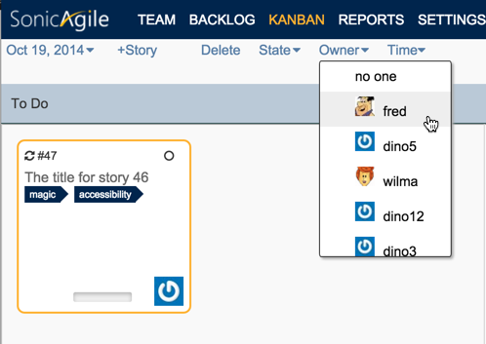](http://sonicagile.com/wp-content/uploads/2014/11/AssignOwner.png)

Assigning time estimates and owners to stories enables you to do resource capacity planning. You can determine whether you are assigning too much work or too little work to different members of your team.

### SonicAgile Insights Agile Iteration Plan Reports

SonicAgile Insights includes several reports that you can use for iteration planning. First, you can use the *Iteration Plan by Story* report to view all of the stories planned for the next iteration and the amount of time estimated for each story.

[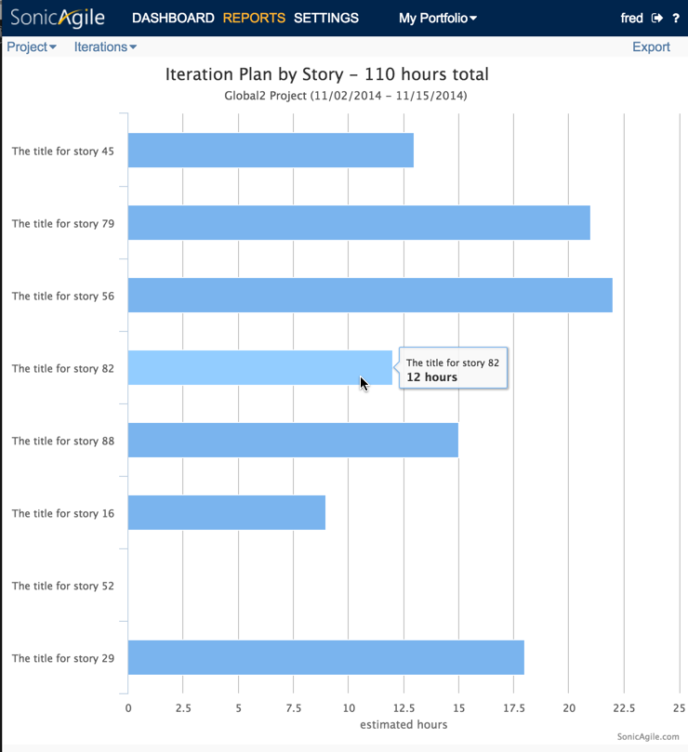](http://sonicagile.com/wp-content/uploads/2014/11/IterationPlanByStory.png)

The *Iteration Plan by Team Member* report enables you to see the total amount of work assigned to each team member. This report enables you to determine whether or not you are assigning too many hours of work to a particular person.

[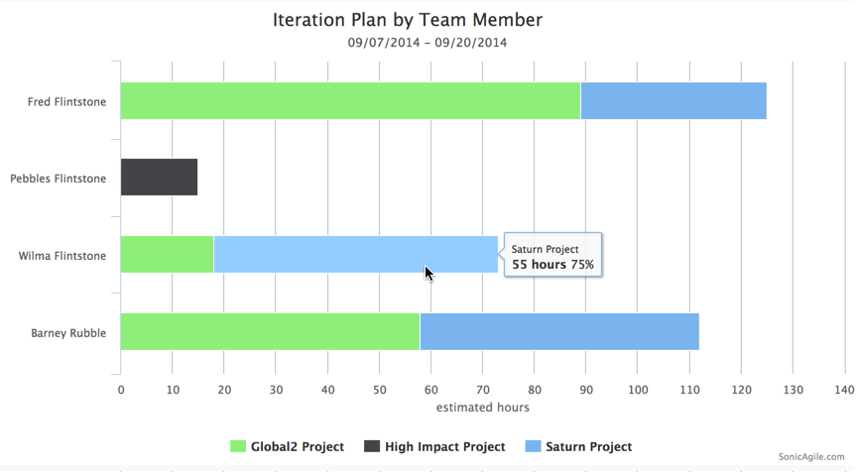](http://sonicagile.com/wp-content/uploads/2014/11/IterationPlanByTeamMember.png)

## Agile Matrix Management

In an ideal world, a single Agile team would always be focused on a single project. In the real world, however, a single team is often responsible for multiple unrelated projects.

Making things even more complicated, a single person might need to divide his/her time across the different projects. For example, team member Sally might need to devote her time to the following three projects:

* Project A – 25% of her time.
* Project B – 25% of her time.
* Project C – 50% of her time.

SonicAgile supports Agile Matrix Management. You can use SonicAgile Insights to balance people’s time across multiple projects in the same iteration.

There are two reports included in SonicAgile Insights that are useful for Matrix Management. First, you can use the *Iteration Plan by Team Member* report to view the amount of time each person is planned to work on each project. In other words, the*Iteration Plan by Team Member* report is a cross-project report that you can use for resource capacity planning.

[](http://sonicagile.com/wp-content/uploads/2014/11/IterationPlanByTeamMember.png)

The *Iteration Plan by Team Member* report is useful for determining whether you are assigning too much work to a particular team member. You can use this report to easily see all of the work assigned to a person across multiple projects.

Second, you can use the *Iteration Plan by Project* report to ensure that high priority projects are getting more attention than low priority projects. The report compares the total number of hours planned for each project in the next iteration.

[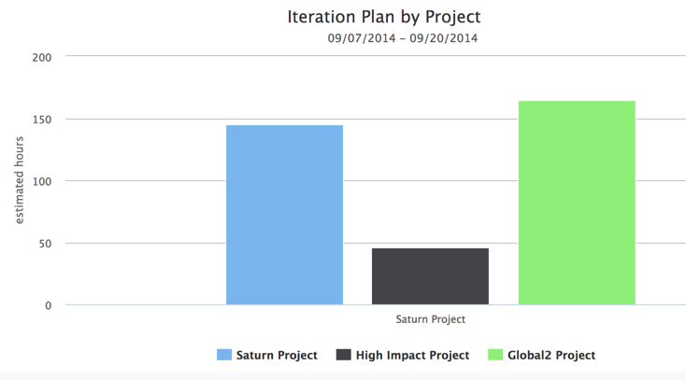](http://sonicagile.com/wp-content/uploads/2014/11/IterationPlanByProject1.png)

## Scrum of Scrums

During an iteration, you can use SonicAgile Insights to ensure that all of the projects in your portfolio are on track. SonicAgile Insights is especially useful during Scrum of Scrum meetings when you need to view the progress of multiple projects and multiple teams.

SonicAgile Insights includes a cross-project dashboard that enables you to view Key Performance Indicators (KPIs) for all the projects in your portfolio. For example, you can use the dashboard to view the percentage of a release completed and the percentage of the work completed for each project.

[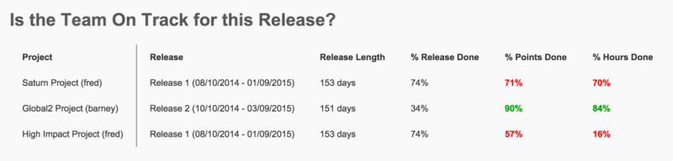](http://sonicagile.com/wp-content/uploads/2014/11/Dashboard-e1417446516798.png)

And, you can use SonicAgile Insights cross-project reports to view information on multiple projects in a single report. For example, the cross-project *Iteration Burndown by Time* report displays burndown lines for all of the projects in your portfolio.

[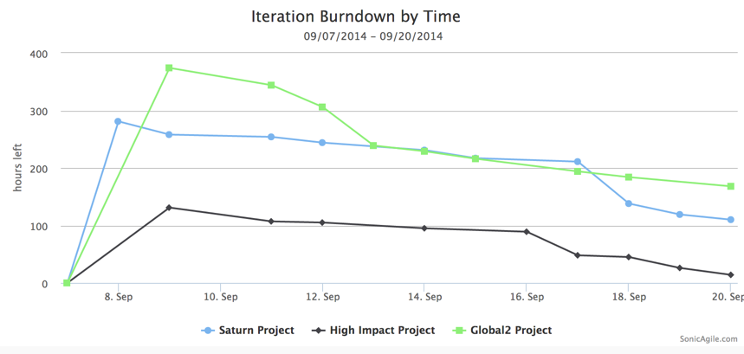](http://sonicagile.com/wp-content/uploads/2014/11/IterationBurndownByTime1.png)

## Agile Time Tracking

Up to this point, we have focused on all of the SonicAgile features for release and iteration planning. In this section, you learn about the SonicAgile features that you can use for Time Tracking.

SonicAgile enables you to track three time related properties for each story:

* Original Estimate – The original time estimate for a story. Normally, you enter this value when you first create a story.
* Time Left – The time left to complete the story. When you first create a story, the time left is the same as the original estimate.
* Time Spent – The time already spent working on the story.

Typically, an Agile team updates the time left and time spent for each story in an iteration during the Daily Standup meeting. You can easily update time left and time spent from the Kanban toolbar menu.

[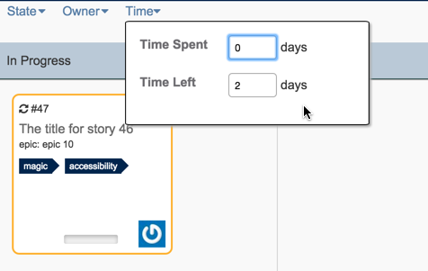](http://sonicagile.com/wp-content/uploads/2014/11/UpdateTime.png)

The time left and time spent properties are completely independent – they must be updated separately each day. The reason is that, in real life, the estimated time left for a story will change day by day independently of the time spent. So, if you want an accurate representation of the remaining work in an iteration then you need to update time left and time spent separately.

SonicAgile Insights has several reports that are related to time tracking. Both the *Release Burndown by Time* and *Iteration Burndown by Time* reports enable you to track team progress. Both of these reports display the remaining number of hours left in an iteration to complete all of the work.

[](http://sonicagile.com/wp-content/uploads/2014/11/IterationBurndownByTime1.png)

Finally, the *Time by Team Member* report enables you to see how much time each member of your team actually spent completing the work in an iteration. You can use this report, for example, for billing purposes.

[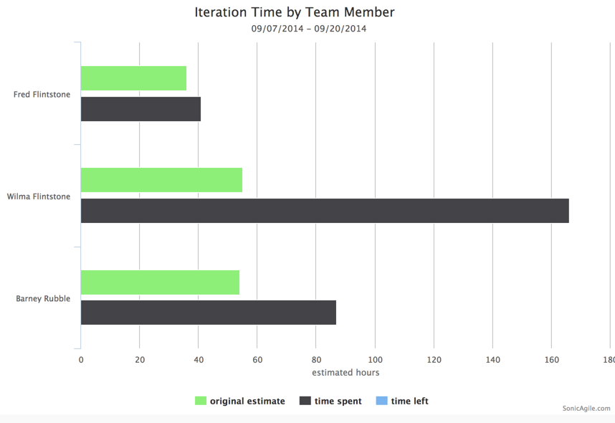](http://sonicagile.com/wp-content/uploads/2014/11/IterationTimeByTeamMember1.png)

## Summary

SonicAgile was designed to support enterprise Agile project management. You can use SonicAgile for Agile Release Planning, Agile Iteration Planning, and Time Tracking.

You can take advantage of SonicAgile Insights for Agile Portfolio Management. The SonicAgile Insights dashboard displays Key Performance Indicators (KPIs) for all of the projects in your portfolio.

SonicAgile Insights also has more than a dozen reports that you can use to manage your projects including reports that can be used for Agile Release Planning, Agile Iteration Planning, and Scrum of Scrum meetings. Most of these reports are cross-project reports.

**A Guide to using SonicAgile for Quality Assurance Engineers**

How do you do testing when working in an Agile team?

Let me start by explaining what I mean by testing. By testing, I don’t mean automated testing. Your automated tests should be run automatically during code check-in or, if the tests take a long time to run, during a nightly build.

By testing, I am referring to manual testing: the hands-on, non-automated, testing that is performed by Quality Assurance Engineers. You need to perform both automated and manual testing when producing a high-quality product.

There are two times that you need to perform manual testing: during an iteration and immediately before a release. SonicAgile was designed to support both iteration and release testing.

**Enabling Testing**

Before you can take advantage of any of the SonicAgile testing features, you must first enable Testing. Follow these steps:

1. Login to SonicAgile at http://SonicAgile.com.
2. Navigate to your project settings by clicking the Settings link.
3. Select the Tests tab.
4. Click the checkbox labeled Enable tests.

After you complete these steps, you will be able to add tests to your project.

**Testing During an Iteration**

During an iteration, you need to test each story included in the iteration. You want to ensure that each story is thoroughly tested before the story is done.

Normally, you create at least two tasks for each story: a Code task and a Test task. For example, if your iteration includes a Create a Shopping Cart story then your Kanban would look like this at the start of the iteration:

[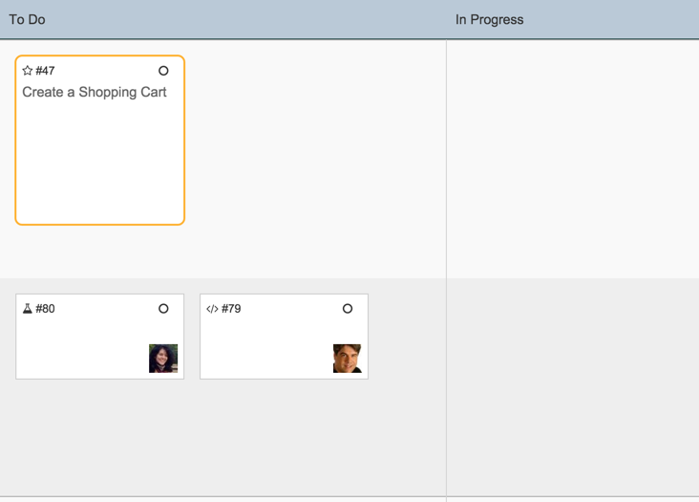](http://sonicagile.com/wp-content/uploads/2014/12/KanbanStart.png)

The Create a Shopping Cart story has two tasks. The story has a testing task (owned by Quality Engineer Ruth) and a coding task (owned by Developer Stephen). At the start of the iteration, the story and both tasks are in the To Do column.

When Developer Stephen starts work on the Create a Shopping Cart story, he moves both the story and the coding task into the In Progress column and the Kanban looks like this:

[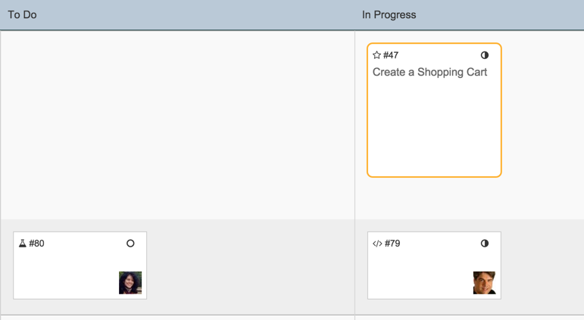](http://sonicagile.com/wp-content/uploads/2014/12/KanbanInProgress.png)

While Developer Stephen is working on the story, he adds one or more tests to the story. Typically the steps are added in consultation with the Quality Assurance Engineer. Follow these steps to a add a test to the story:

1. Double click the story to open the story dialog.
2. Select the Tests tab.
3. Click the +Test button to open the New Test dialog.
4. Enter a Test Name, Test Steps, and a Test Priority.

[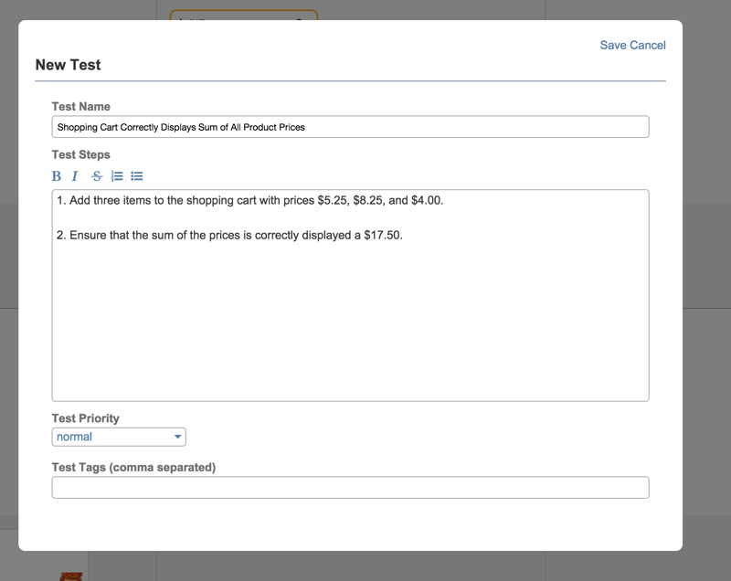](http://sonicagile.com/wp-content/uploads/2014/12/NewTest.png)

After Developer Stephen finishes the coding tasks, and adds a set of tests to the story, then Quality Engineer Ruth can start testing the story. When she starts testing then she should move the Test task to the In Progress column.

[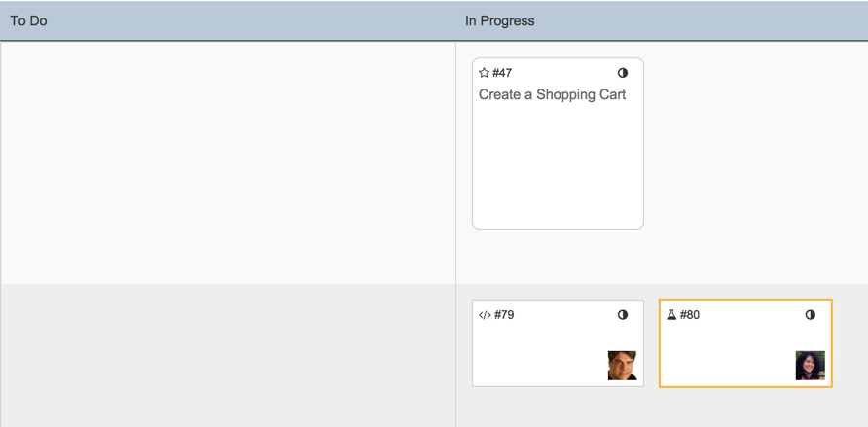](http://sonicagile.com/wp-content/uploads/2014/12/TestingInProgress.png)

Quality Assurance Engineer Ruth can run each test by clicking the Run button next to each test under the Tests tab. When she runs a test, she can mark the test as failing or passing:

[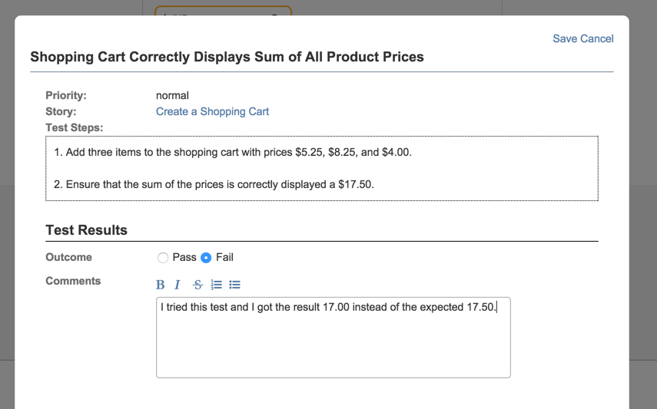](http://sonicagile.com/wp-content/uploads/2014/12/runTest.png)

If a story has failing tests then the story appears with a warning icon on both the Kanban and the Backlog:

[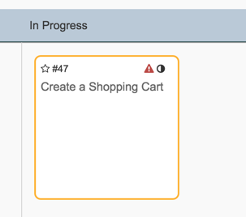](http://sonicagile.com/wp-content/uploads/2014/12/FailingStory.png)

Developer Stephen can open the card to see the list of all of the failing tests:

[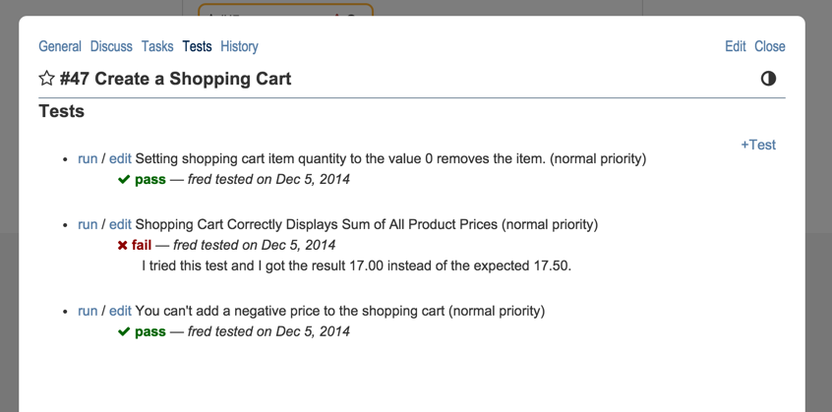](http://sonicagile.com/wp-content/uploads/2014/12/TestHistory.png)

After Developer Stephen addresses the issues in the tests, Quality Engineer Ruth can rerun the tests. If all of the tests pass then the story and both of its tasks can be moved to the Done column. All of the work is done and the story has been tested.

[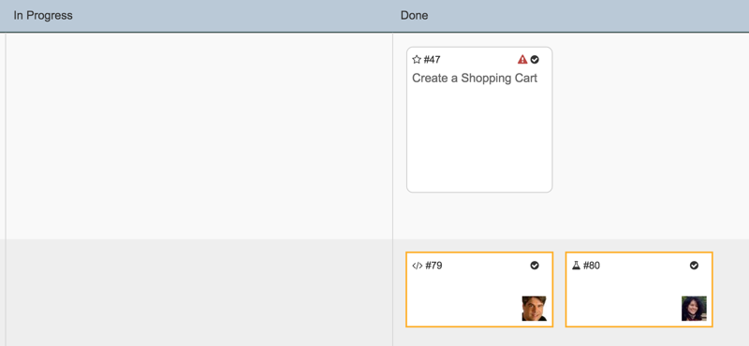](http://sonicagile.com/wp-content/uploads/2014/12/AllDone.png)

Testing during an iteration is good practice because it enables developers to address issues in their code immediately after the developer has written the code. It is always much easier to fix code problems immediately after the code is written instead of waiting until the developer has started to focus on new coding problems.

**Testing Before a Release**

In addition to iteration testing, you also should perform release testing. You should test your product immediately before each product release. Typically, you don’t test everything before a release. Instead, you perform only high priority tests to ensure that nothing critical is broken.

SonicAgile enables you to define a Test Run. A Test Run is simply a collection of tests where the tests can be from multiple iterations. Normally, you add all of your high priority tests to a test run.

Here are the steps for creating a new Test Run:

* + 1. Select the top-level Tests tab to navigate to the Tests page.
    2. Click the +Test Run button to open the New Test Run dialog.
    3. Select the tests that you want to include in the test run by filtering all of the tests in your project by priority and tags.
    4. Click the Save button to save the new Test Run.

[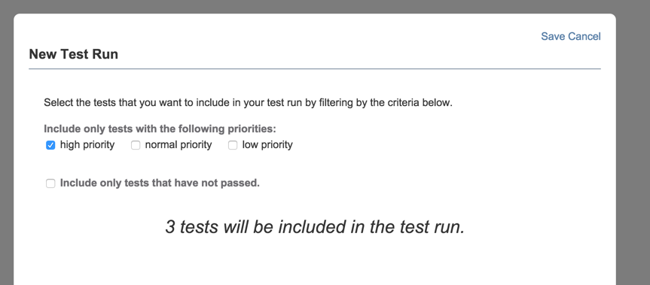](http://sonicagile.com/wp-content/uploads/2014/12/NewTestRun.png)

After you create a Test Run, a Quality Assurance Engineer can open the Test Run and run all of its tests. You can see the progress that the Quality Assurance Engineer makes on performing each test in the test run:

[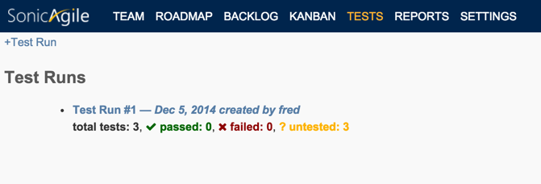](http://sonicagile.com/wp-content/uploads/2014/12/TestRun.png)

If any of the tests fail during the Test Run then you can create a new Test Run that contains only the failing tests. SonicAgile can do this for you automatically, with the click of a button. It might take multiple test runs before all issues are resolved before a release.

**Summary**

Testing is an important part of producing any successful product. If you want to ensure that you are producing a quality product then your stories should include testing tasks.

SonicAgile enables you to associate one or more tests with any story. You can run the tests during an iteration and you can run the tests immediately before a product release. SonicAgile makes testing easy for the Agile team.

**Tutorials – Why Use SonicAgile?**

SonicAgile contains all of the standard Agile tools such as a Backlog, Kanban, and Burndown Charts. In addition, SonicAgile has several features which make it unique:

* **Realtime** — See changes made to the SonicAgile Backlog and Kanban in realtime. When one user makes a change to the Backlog or Kanban, every other user sees the change without needing to refresh their browser. This is an especially useful feature when working in a distributed team. Someone can make a change to the Kanban in one geographical location and everyone else can see the change instantly.
* **Agile Estimation** — Estimate the amount of work required to complete stories using Fibonacci numbers, coffee cup sizes, shirt sizes, or raw points. View your team’s progress over an iteration by using Burndown Charts.
* **Acceptance Criteria** — Ensure that a story really gets done by creating acceptance criteria. Acceptance criteria are a list of requirements for determining when a story is done.
* **Agile Testing** — Create a set of tests for each story and re-run the tests for each release. Ensure that the critical functionality in your product works before your product is released.
* **Agile Time Tracking** — Easily track the original estimate, time left, and time spent for each story and task. Using SonicAgile Insights, you can view detailed reports on how much time is being spent by each member of your team for each project in each iteration.
* **Agile Release Planning** — Use epics and releases to create a release plan. Use reports to view the total estimated amount of work required for a release.
* **Agile Resource Capacity Planning** — Plan work across multiple projects. Using SonicAgile Insights, you can do Agile Matrix Management by allocating developer time across multiple projects.
* **Agile Portfolio Management** — Create a portfolio with one or more SonicAgile projects and share cross-project reports with other managers in your organization.

Learn how to take advantage of all of these features in the following tutorials.